   





FLAVIO COPES

# Table of Contents

Introduction Intro to Vue

Introduction to Vue Vue First App

Tooling

The Vue CLI DevTools

Configuring VS Code for Vue Development Components

Components

Single File Components Templates

Styling components using CSS Components building blocks

Directives Events Methods Watchers

Computed Properties

Methods vs Watchers vs Computed Properties Props

Slots Filters

Communication, state management and routing Communication among components

Vuex

Vue Router

# Introduction

Thank you for getting this ebook!

My name is Flavio and I run a blog at [flaviocopes.com](https://flaviocopes.com/), where I write a tutorial every day. You can find me on Twitter at [@flaviocopes](https://twitter.com/flaviocopes)

At the end of July 2018, I will launch an online course on Vue.js with practical tutorials and direct mentorship from me.

Find out more at [vuecourse.com](https://vuecourse.com/)! Happy learning!

# Introduction to Vue

#### Vue is a very impressive project. It's a very popular JavaScript framework, one that's experiencing a huge growth. It is simple, tiny and very performant. Learn more about it

First, what is a JavaScript frontend framework? The popularity of Vue

Why developers love Vue

Where does Vue.js position itself in the frameworks landscape Vue.js is an indie project

Vue is a very popular JavaScript frontend framework, one that's experiencing a huge growth.

It is simple, tiny (~24KB) and very performant. It feels different from all the other JavaScript frontend frameworks and view libraries. Let's find out why.

## First, what is a JavaScript frontend framework?

If you're unsure what a JavaScript framework is, Vue is the perfect first encounter with one.

A JavaScript framework helps us to create modern applications. Modern JavaScript applications are mostly used on the Web, but also power a lot of Desktop and Mobile applications.

Until the early 2000s, browsers didn't have the capabilities they have now. They were a lot less powerful, and building complex applications inside them was not feasible performance- wise, and the tooling was not even something that people thought about.

Everything changed when Google unveiled Google Maps and GMail, two applications that ran inside the browser. Ajax made asynchronous network requests possible, and over time developers started building on top of the Web platform, while engineers worked on the platform itself: browsers, the Web standards, the browser APIs, and the JavaScript language.

Libraries like jQuery and Mootools were the first big projects that built upon JavaScript and were hugely popular for a while. They basically provided a nicer API to interact with the browser and provided workarounds for bugs and inconsistencies among the various browsers.

Frameworks like Backbone, Ember, Knockout, AngularJS were the first wave of modern JavaScript frameworks. The second wave, which is the current one, has React, Angular, and Vue as its main actors.

Note that jQuery, Ember and the other projects I mentioned are still being heavily used, actively maintained, and millions of websites rely on them. That said, techniques and tools evolve, and as a JavaScript developer, you're now likely to be required to know React, Angular or Vue rather than those older frameworks.

Frameworks abstract the interaction with the browser and the DOM. Instead of manipulating elements by referencing them in the DOM, we **declaratively** define and interact with them, at a higher level.

Using a framework is like using the C programming language instead of using the Assembly language to write system programs. It's like using a computer to write a document instead of using a typewriter. It's like having a self-driving car instead of driving the car yourself.

Well, not that far, but you get the idea. Instead of using low-level APIs offered by the browser to manipulate elements, and build hugely complex systems to write an application, **you use tools built by very smart people that make our life easier**.

## The popularity of Vue

How much popular is Vue.js? Vue had:

7600 stars on GitHub in 2016

36700 stars on GitHub in 2017

and it has more than 100.000+ stars on GitHub, as of June 2018.

Its npm download count is growing every day, and now it's at ~350.000 downloads per week. I would say Vue is **a lot popular**, given those numbers.

In relative terms, it has approximately the same numbers of GitHub stars of React, which was born years before.

Numbers are not everything, of course. The impression I have of Vue is that developers *love* it.

A key point in time of the rise of Vue has been the adoption in the Laravel ecosystem, a hugely popular PHP web application framework, but since then it has widespread among many other development communities.

## Why developers love Vue

First, Vue is called a **progressive framework**.

This means that it adapts to the needs of the developer. While other frameworks require a complete buy-in from a developer or team and often want you to rewrite an existing application because they require some specific set of conventions, Vue happily lands inside your app with a simple script tag, to start with, and it can grow along with your needs, spreading from 3 lines to managing your entire view layer.

You don't need to know about webpack, Babel, npm or anything to get started with Vue, but when you're ready Vue makes it simple for you to rely on them.

This is one great selling point, especially in the current ecosystem of JavaScript frontend frameworks and libraries that tends to alienate newcomers and also experienced developers that feel lost in the ocean of possibilities and choices.

Vue.js is probably the more approachable frontend framework around. Some people call Vue the *new jQuery*, because it easily gets in the application via a script tag, and gradually gains space from there. Think of it as a compliment, since jQuery dominated the Web in the past few years, and it still does its job on a huge number of sites.

Vue picks from the best ideas. It was built by picking the best ideas of frameworks like Angular, React and Knockout, and by cherry-picking the best choices those frameworks made, and excluding some less brilliant ones, it kind of started as a "best-of" set and grew from there.

## Where does Vue.js position itself in the frameworks landscape

The 2 elephants in the room, when talking about web development, are **React** and **Angular**. How does Vue position itself relative to those 2 big and popular frameworks?

Vue was created by Evan You when he was working at Google on AngularJS (Angular 1.0) apps and was born out of a need to create more performant applications. Vue picked some of the Angular templating syntax, but removed the opinionated, complex stack that Angular required, and made it very performant.

The new Angular (Angular 2.0) also solved many of the AngularJS issues, but in very different ways, and requires a buy-in to TypeScript which not all developers enjoy using (or want to learn).

What about React? Vue took many good ideas from React, most importantly the Virtual DOM. But Vue implements it with some sort of automatic dependency management, which tracks which components are affected by a change of the state so that only those components are re- rendered when that state property changes. In React on the other hand when a part of the state that affects a component changes, the component will be re-rendered and by default all its children will be rerendered as well. To avoid this you need to use the

shouldComponentUpdate method of each component and determine if that component should be rerendered. This gives Vue a bit of advantage in terms of ease of use, and out of the box performance gains.

One big difference with React is JSX. While you can technically use JSX in Vue, it's not a popular approach and instead the templating system is used. Any HTML file is a valid Vue template, while JSX is very different than HTML and has a learning curve for people in the team that might only need to work with the HTML part of your app, like designers. Vue templates are a lot similar to Mustache and Handlebars (although they differ in terms of flexibility) and as such, they are more familiar to developers that already used frameworks like Angular and Ember.

The official state management library, Vuex, follows the Flux architecture and is somewhat similar to Redux in its concepts. Again, this is part of the positive things about Vue, which saw this good pattern in React and borrowed it to its ecosystem. And while you can use Redux with Vue, Vuex is specifically tailored for Vue and its inner workings.

Vue is flexible but the fact that the core team maintains two packages very important for any web app like routing and state management makes it a lot less fragmented than React for example: vue-router and vuex are key to the success of Vue. You don't need to choose or worry if that library you chose is going to be maintained in the future and will keep up with framework updates, and being official they are the canonical go-to libraries for their niche (but you can choose to use what you like, of course).

One thing that puts Vue in a different bucket compared to React and Angular is that Vue is an *indie* project: it's not backed by a huge corporation like Facebook or Google. Instead, it's completely backed by the community, which fosters development through donations and sponsors. This makes sure the roadmap of Vue is not driven by a single company agenda.

# Vue First App

#### If you've never created a Vue.js application, I am going to guide you through the task of creating one, and understanding how it works. The app we're going to build is already done, and it's the Vue CLI default application

First example

See on Codepen

Second example: the Vue CLI default app Use the Vue CLI locally

Use CodeSandbox The files structure

index.html

src/main.js

src/App.vue

src/components/HelloWorld.vue

Run the app

If you've never created a Vue.js application, I am going to guide you through the task of creating one, and understanding how it works.

## First example

First I'll use the most basic example of using Vue. You create an HTML file which contains

<html>

<body>

<div id="example">

<p>{{ hello }}</p>

</div>

<script src="https://unpkg.com/vue"></script>

<script>

new Vue({

el: '#example',

data: { hello: 'Hello World!' }

})

</script>

</body>

</html>

and you open it in the browser. That's your first Vue app! The page should show a "Hello World!" message.

I put the script tags at the end of the body so that they are executed in order after the DOM is loaded.

What this code does is, we instantiate a new Vue app, linked to the #example element as its template (it's defined using a CSS selector usually, but you can also pass in an HTMLElement).

Then, it associates that template to the data object. That is a special object that hosts the data we want Vue to render.

In the template, the special {{ }} tag indicates that's some part of the template that's dynamic, and its content should be looked up in the Vue app data.

### See on Codepen

You can see this example on Codepen: <https://codepen.io/flaviocopes/pen/YLoLOp>

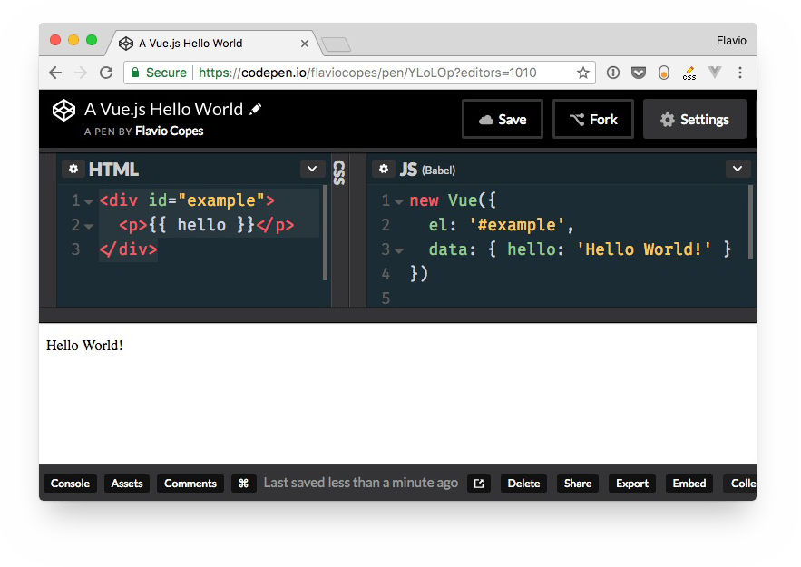

Codepen is a little different from using a plain HTML file, and you need to configure it to point to the Vue library location in the Pen settings:

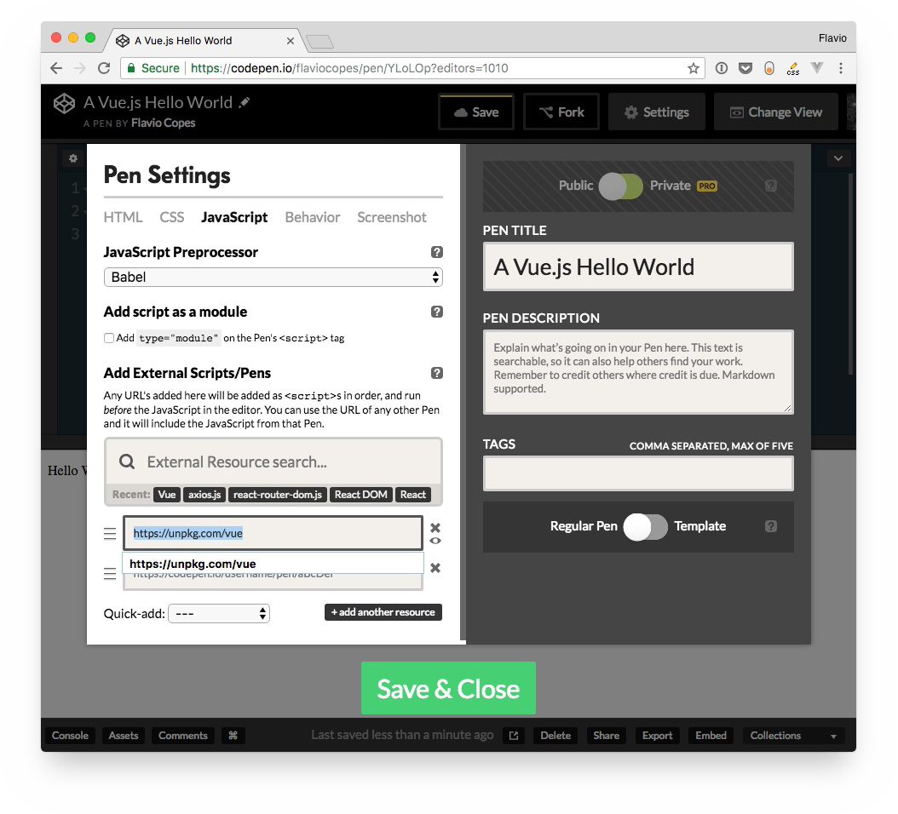

## Second example: the Vue CLI default app

Let's level up the game a little bit. The next app we're going to build is already done, and it's

**the Vue CLI default application**.

What is the Vue CLI? It's a command line utility that helps to speed up development by scaffolding an application skeleton for you, with a sample app in place.

There are two ways you can get this application.

### Use the Vue CLI locally

The first is to install the Vue CLI on your computer, and run the command

vue create <enter the app name>

### Use CodeSandbox

A simpler way, without having to install anything, is to go to <https://codesandbox.io/s/vue>.

CodeSandbox is a cool code editor that allows you build apps in the cloud, which allows you to use any npm package and also easily integrate with Zeit Now for an easy deployment and GitHub to manage versioning.

That link I put above opens the Vue CLI default application.

Whether you chose to use the Vue CLI locally, or through CodeSandbox, let's inspect that Vue app in details.

### The files structure

Beside package.json , which contains the configuration, these are the files contained in the initial project structure:

index.html

src/App.vue

src/main.js

src/assets/logo.png

src/components/HelloWorld.vue

#### index.html

The index.html file is the main app file.

In the body it includes just one simple element: <div id="app"></div> . This is the element the Vue application will use to attach to the DOM.

<!DOCTYPE html>

<html>

<head>

<meta charset="utf-8">

<meta name="viewport" content="width=device-width,initial-scale=1.0">

<title>CodeSandbox Vue</title>

</head>

<body>

<div id="app"></div>

<!-- built files will be auto injected -->

</body>

</html>

#### src/main.js

This is the main JavaScript files that drive our app.

We first import the Vue library and the App component from App.vue .

We set productionTip to false, just to avoid Vue to output a "*you're in development mode*" tip in the console.

Next, we create the Vue instance, by assigning it to the DOM element identified by #app , which we defined in index.html , and we tell it to use the App component.

// The Vue build version to load with the `import` command

// (runtime-only or standalone) has been set in webpack.base.conf with an alias. import Vue from 'vue'

import App from './App' Vue.config.productionTip = false

/* eslint-disable no-new */ new Vue({

el: '#app', components: { App }, template: '<App/>'

})

#### src/App.vue

App.vue is a Single File Component. It contains 3 chunks of code: HTML, CSS and JavaScript.

This might seem weird at first, but Single File Components are a great way to create self- contained components that have all they need in a single file.

We have the markup, the JavaScript that is going to interact with it, and style that's applied to it, which can be scoped, or not. In this case, it's not scoped, and it's just outputting that CSS which is applied like regular CSS to the page.

The interesting part lies in the script tag.

We import a **component** from the components/HelloWorld.vue file, which we'll describe later.

This component is going to be referenced in our component. It's a dependency. We are going to output this code:

<div id="app">

<img width="25%" src="./assets/logo.png">

<HelloWorld/>

</div>

from this component, which you see references the HelloWorld component. Vue will automatically insert that component inside this placeholder.

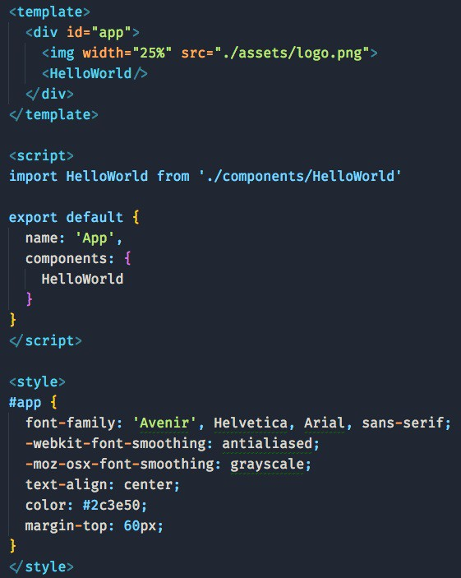

#### src/components/HelloWorld.vue

Here's the HelloWorld component, which is included by the App component. This component outputs a set of links, along with a message.

Remember above we talked about CSS in App.vue, which was not scoped? The HelloWorld component has scoped CSS.

You can easily determine it by looking at the style tag. If it has the scoped attribute, then it's scoped: <style scoped>

This means that the generated CSS will be targeting the component uniquely, via a class that's applied by Vue transparently. You don't need to worry about this, and you know the CSS won't *leak* to other parts of the page.

The message the component outputs is stored in the data property of the Vue instance, and outputted in the template as {{ msg }} .

Anything that's stored in data is reachable directly in the template via its own name. We didn't need to say data.msg , just msg .

<template>

<div class="hello">

<h1>{{ msg }}</h1>

<h2>Essential Links</h2>

<ul>

<li>

<a

href="https://vuejs.org" target="_blank"

>

Core Docs

</a>

</li>

<li>

<a

href="https://forum.vuejs.org" target="_blank"

>

Forum

</a>

</li>

<li>

<a

href="https://chat.vuejs.org" target="_blank"

>

Community Chat

</a>

</li>

<li>

<a

href="https://twitter.com/vuejs" target="_blank"

>

Twitter

</a>

</li>

<br>

<li>

<a

href="<http://vuejs-templates.github.io/webpack/>" target="_blank"

>

Docs for This Template

</a>

</li>

</ul>

<h2>Ecosystem</h2>

<ul>

<li>

<a

href="<http://router.vuejs.org/>" target="_blank"

>

vue-router

</a>

</li>

<li>

<a

href="<http://vuex.vuejs.org/>" target="_blank"

>

vuex

</a>

</li>

<li>

<a

href="<http://vue-loader.vuejs.org/>" target="_blank"

>

vue-loader

</a>

</li>

<li>

<a

href="https://github.com/vuejs/awesome-vue" target="_blank"

>

awesome-vue

</a>

</li>

</ul>

</div>

</template>

<script>

export default { name: 'HelloWorld', data() {

return {

msg: 'Welcome to Your Vue.js App'

}

}

}

</script>

<!-- Add "scoped" attribute to limit CSS to this component only -->

<style scoped> h1,

h2 {

font-weight: normal;

}

ul {

list-style-type: none; padding: 0;

}

li {

display: inline-block; margin: 0 10px;

}

a {

color: #42b983;

}

</style>

### Run the app

CodeSandbox has a cool preview functionality. You can run the app and edit anything in the source to have it immediately reflected in the preview.

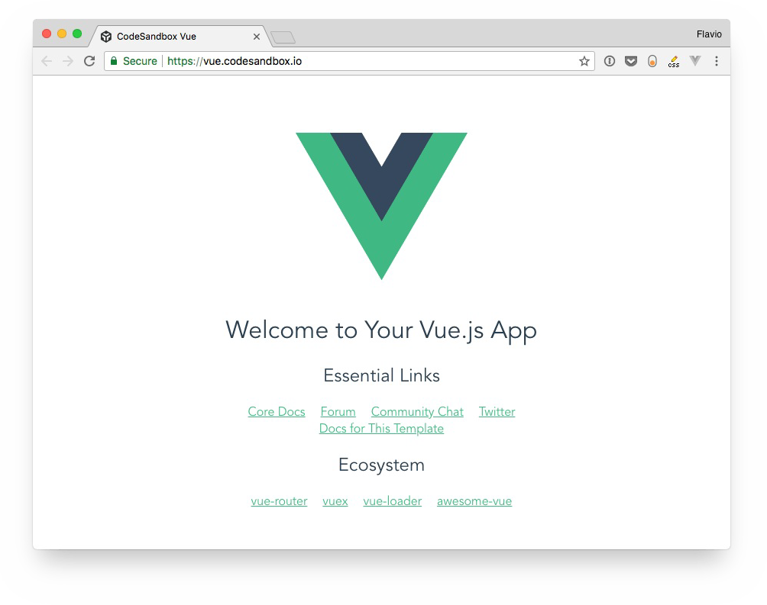

CodeSandbox is very cool for online coding and working without having to setup Vue locally. A great way to work locally is by setting up the Vue CLI. Let's find out more about it.

# The Vue CLI

#### Vue is a very impressive project, and in addition to the core of the framework, it maintains a lot of utilities that make a Vue programmer's life easier. One of them is the Vue CLI.

Installation

What does the Vue CLI provide?

How to use the CLI to create a new Vue project How to start the newly created Vue CLI application Git repository

Use a preset from the command line Where presets are stored

Plugins

Remotely store presets

Another use of the Vue CLI: rapid prototyping Webpack

*In the previous example I introduced an example project based on the Vue CLI. What's the Vue CLI exactly, and how it fits in the Vue ecosystem? Also, how to setup a Vue CLI-based project locally? Let's find out!*

Vue is a very impressive project, and in addition to the core of the framework, it maintains a lot of utilities that make a Vue programmer's life easier.

One of them is the Vue CLI.

CLI stands for Command Line Interface.

Note: There is a huge rework of the CLI going on right now, going from version 2 to 3. While not yet stable, I will describe version 3 because it's a huge improvement over version 2, and quite different.

## Installation

The Vue CLI is a command line utility, and you install it globally using npm:

npm install -g @vue/cli

or using Yarn:

yarn global add @vue/cli

Once you do so, you can invoke the vue command.

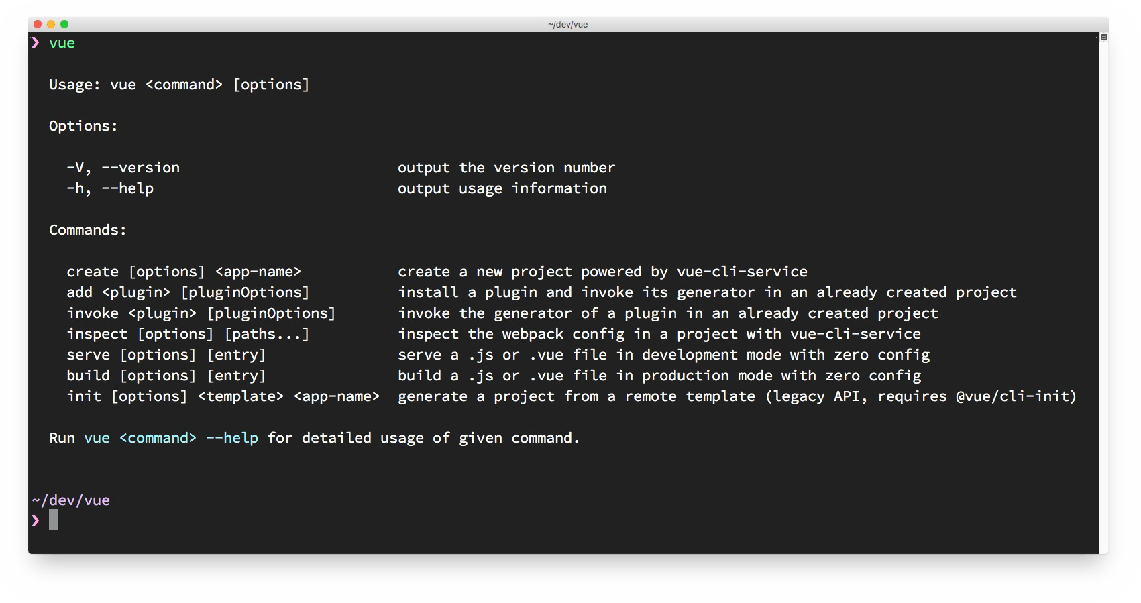

## What does the Vue CLI provide?

The CLI is essential for rapid Vue.js development.

Its main goal is to make sure all the tools you need are working along, to perform what you need, and abstracts away all the nitty-gritty configuration details that using each tool in isolation would require.

It can perform an initial project setup and scaffolding.

It's a flexible tool: once you create a project with the CLI, you can go and tweak the configuration, without having to *eject* your application (like you'd do with create-react-app ).

When you eject from create-react-app you can update and tweak what you want, but you can't rely on the cool features that create-react-app provides

You can configure anything and still be able to upgrade with ease.

After you create and configure the app, it acts as a runtime dependency tool, built on top of webpack.

The first encounter with the CLI is when creating a new Vue project.

## How to use the CLI to create a new Vue project

The first thing you're going to do with the CLI is to create a Vue app:

vue create example

The cool thing is that it's an interactive process. You need to pick a preset. By default, there is one preset that's providing Babel and ESLint integration:

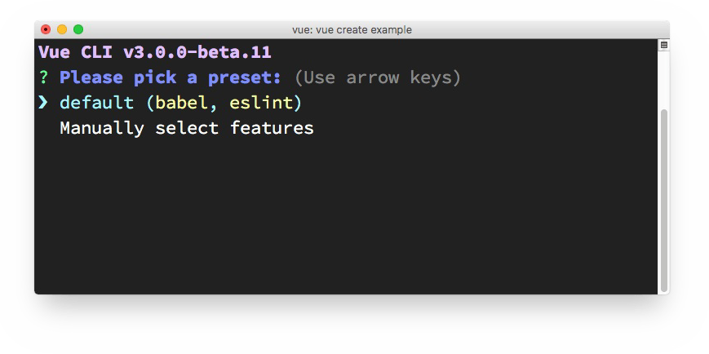

I'm going to press the down arrow ⬇ and manually choose the features I want:

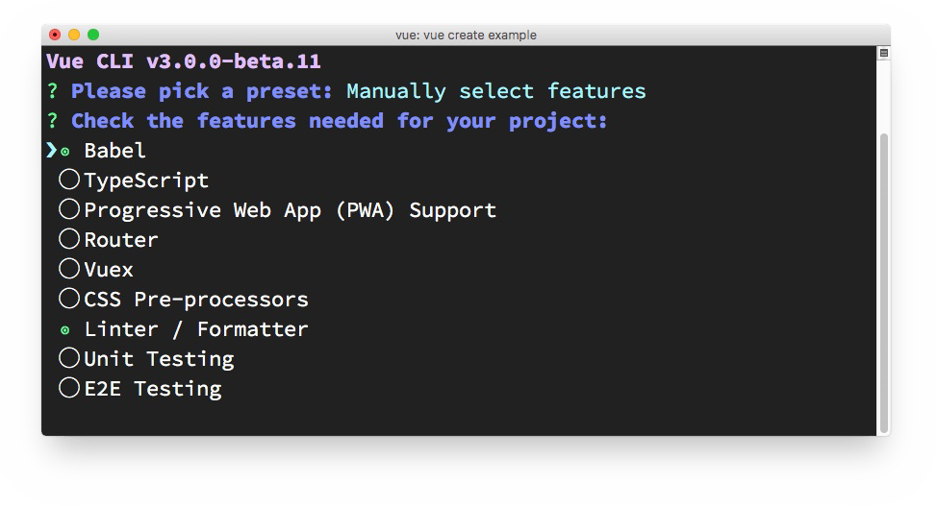

Press space to enable one of the things you need, and then press enter to go on. Since I chose a linter/formatter, Vue CLI prompts me for the configuration. I chose ESLint + Prettier since that's my favorite setup:

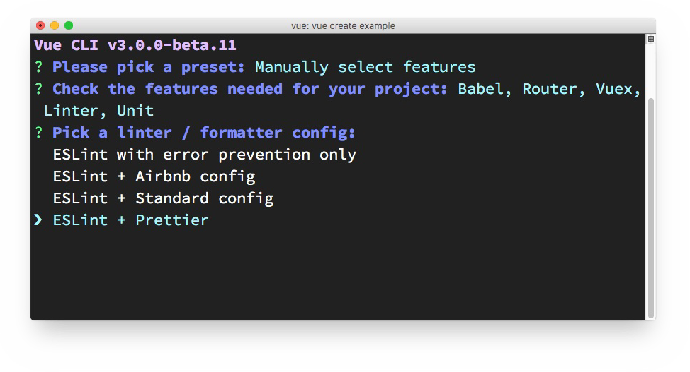

Next thing is choosing how to apply linting. I choose **lint on save**.

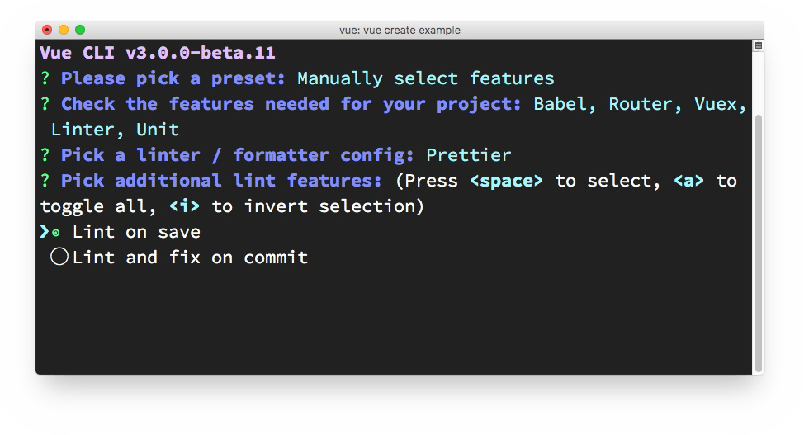

Next up: testing. I picked testing, and Vue CLI offers me to choose between the two most popular solutions: Mocha + Chai vs Jest.

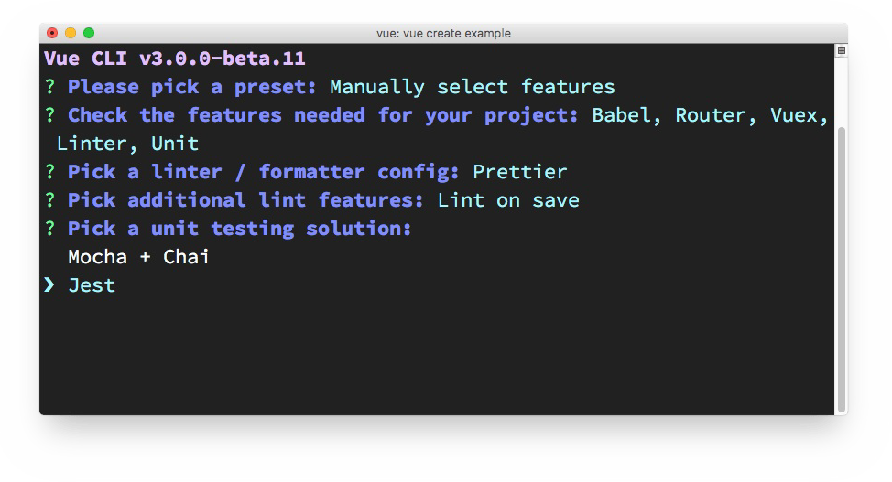

Vue CLI asks me where to put all the configuration: if in the package.json file, or in dedicated configuration files, one for each tool. I chose the latter.

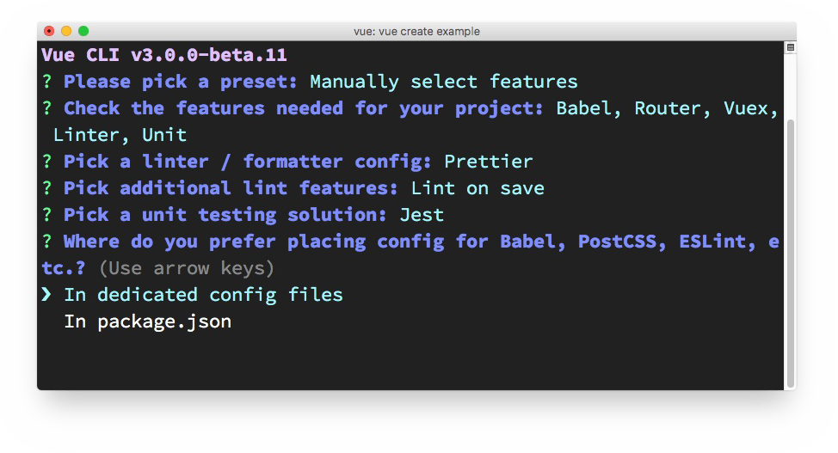

Next, Vue CLI asks me if I want to save these presets, and allow me to pick them as a choice the next time I use Vue CLI to create a new app. It's a very convenient feature, as having a quick setup with all my preferences is a complexity reliever:

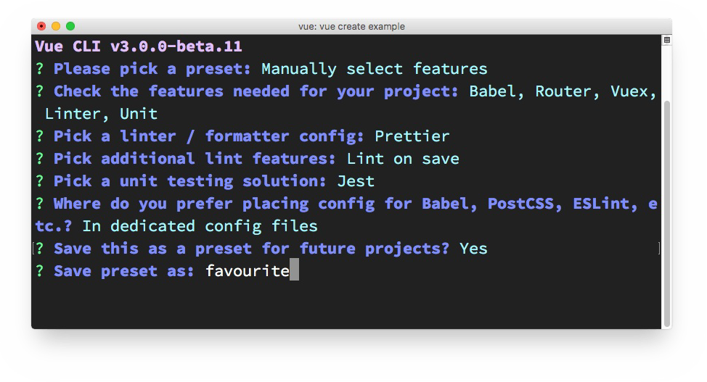

Vue CLI then asks me if I prefer using Yarn or npm:

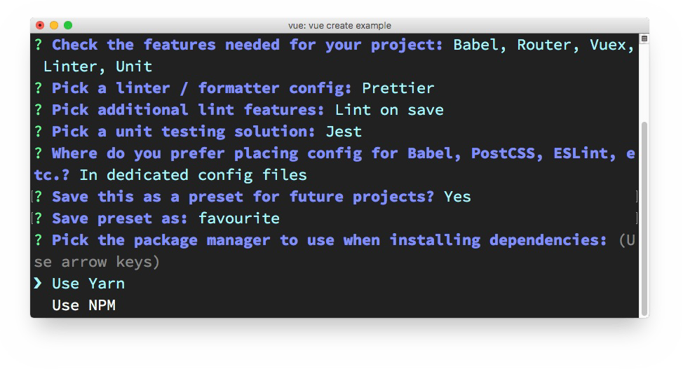

and it's the last thing it asks me, and then it goes on to download the dependencies and create the Vue app:

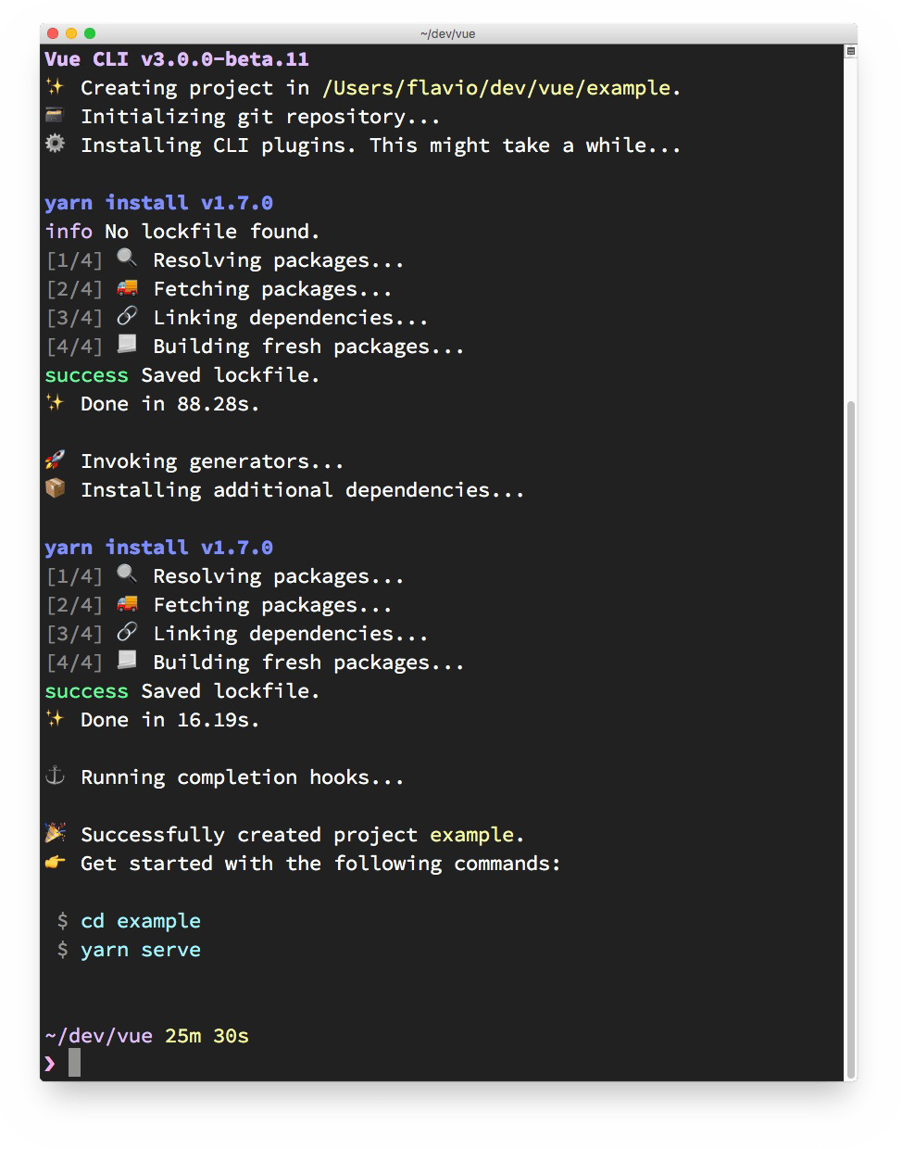

## How to start the newly created Vue CLI application

Vue CLI has created the app for us, and we can go in the example folder and run yarn serve

to start up our first app in development mode:

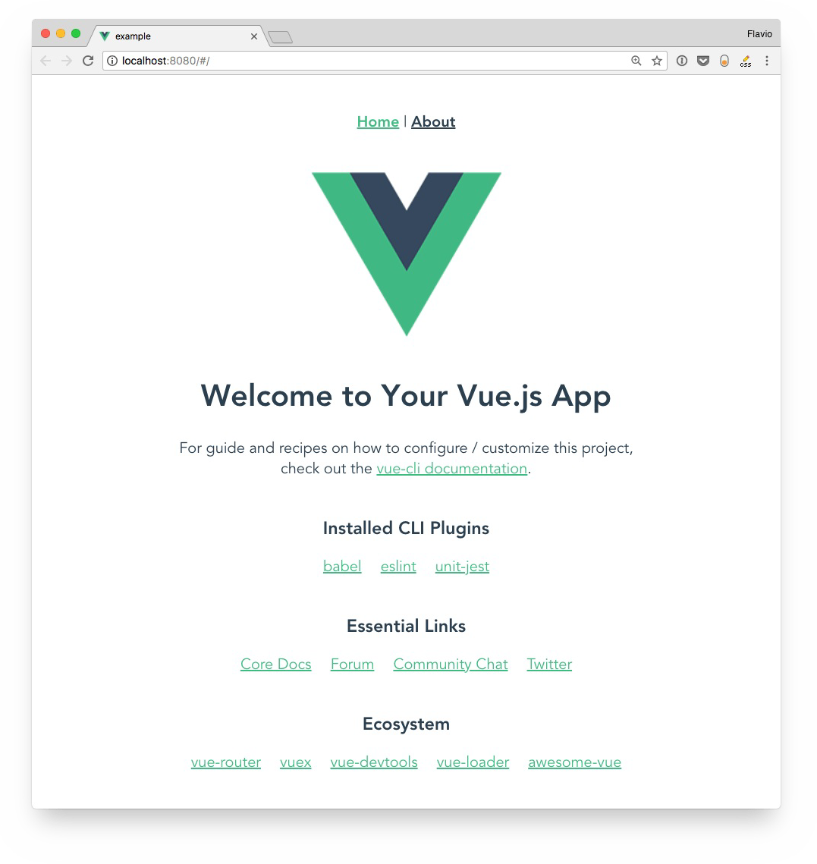

The starter example application source contains a few files, including package.json :

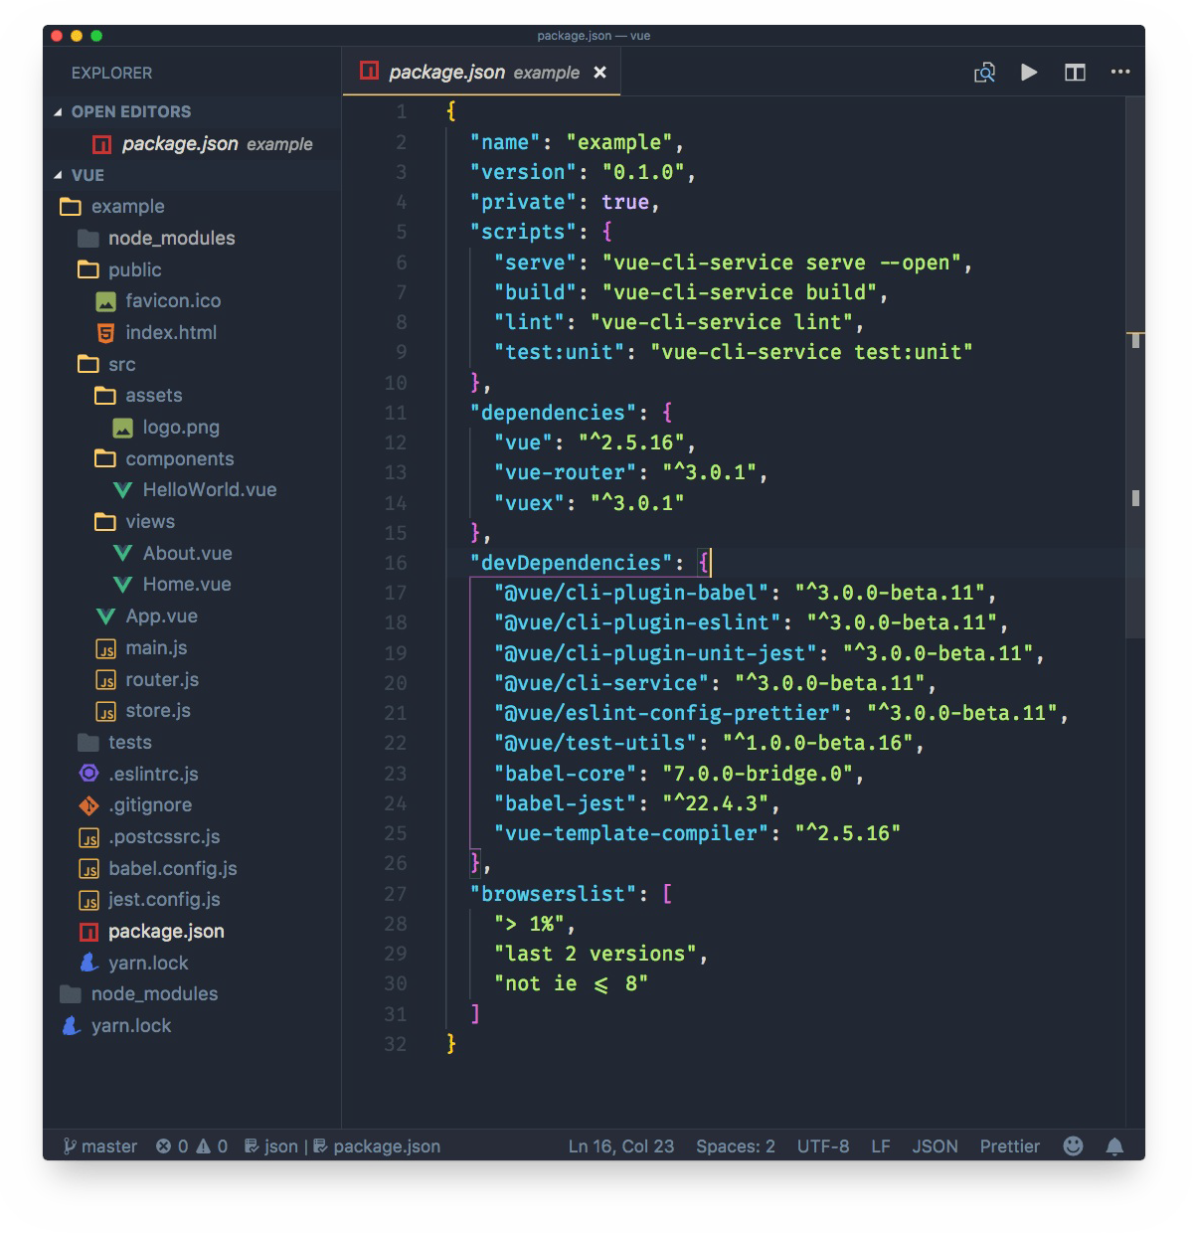

This is where all the CLI commands are defined, including yarn serve , which we used a minute ago. The other commands are

yarn build , to start a production build

yarn lint , to run the linter

yarn test:unit , to run the unit tests

I will describe the sample application generated by Vue CLI in a separate tutorial.

## Git repository

Notice the master word in the lower-left corner of VS Code? That's because Vue CLI automatically creates a repository, and makes the first commit, so we can jump right in, change things, and we know what we changed:

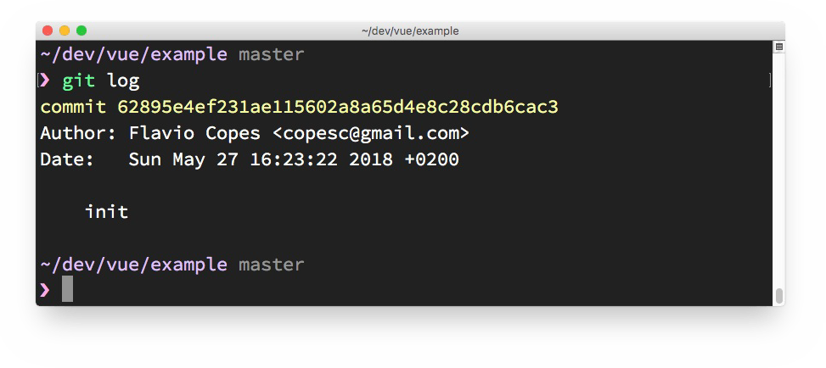

This is pretty cool. How many times you dive in and change things, only to realize when you want to commit the result, that you didn't commit the initial state?

## Use a preset from the command line

You can skip the interactive panel and instruct Vue CLI to use a particular preset:

vue create -p favourite example-2

## Where presets are stored

Presets are stored in the .vuejs file in your home directory. Here's mine after creating the first "favorite" preset

{

"useTaobaoRegistry": false, "packageManager": "yarn", "presets": {

"favourite": { "useConfigFiles": true, "plugins": {

"@vue/cli-plugin-babel": {}, "@vue/cli-plugin-eslint": {

"config": "prettier", "lintOn": [

"save"

]

},

"@vue/cli-plugin-unit-jest": {}

},

"router": true, "vuex": true

}

}

}

## Plugins

As you can see from reading the configuration, a preset is basically a collection of plugins, with some optional configuration.

Once a project is created, you can add more plugins by using vue add :

vue add @vue/cli-plugin-babel

All those plugins are used in the latest version available. You can force Vue CLI to use a specific version by passing the version property:

"@vue/cli-plugin-eslint": { "version": "^3.0.0"

}

this is useful if a new version has a breaking change or a bug, and you need to wait a little bit before using it.

## Remotely store presets

A preset can be stored in GitHub (or on other services) by creating a repository that contains a

preset.json file, which contains a single preset configuration. Extracted from the above, I made a sample preset in <https://github.com/flaviocopes/vue-cli-preset/blob/master/preset.json> which contains this configuration:

{

"useConfigFiles": true, "plugins": {

"@vue/cli-plugin-babel": {}, "@vue/cli-plugin-eslint": {

"config": "prettier", "lintOn": [

"save"

]

},

"@vue/cli-plugin-unit-jest": {}

},

"router": true, "vuex": true

}

It can be used to bootstrap a new application using:

vue create --preset flaviocopes/vue-cli-preset example3

## Another use of the Vue CLI: rapid prototyping

Until now I've explained how to use the Vue CLI to create a new project from scratch, with all the bells & whistles. But for really quick prototyping, you can create a really simple Vue application, even one that's self-contained in a single .vue file, and serve that, without having to download all the dependencies in the node_modules folder.

How? First install the cli-service-global global package:

npm install -g @vue/cli-service-global

//or

yarn global add @vue/cli-service-global

Create an app.vue file:

<template>

<div>

<h2>Hello world!</h2>

<marquee>Heyyy</marquee>

</div>

</template>

and then run

vue serve app.vue

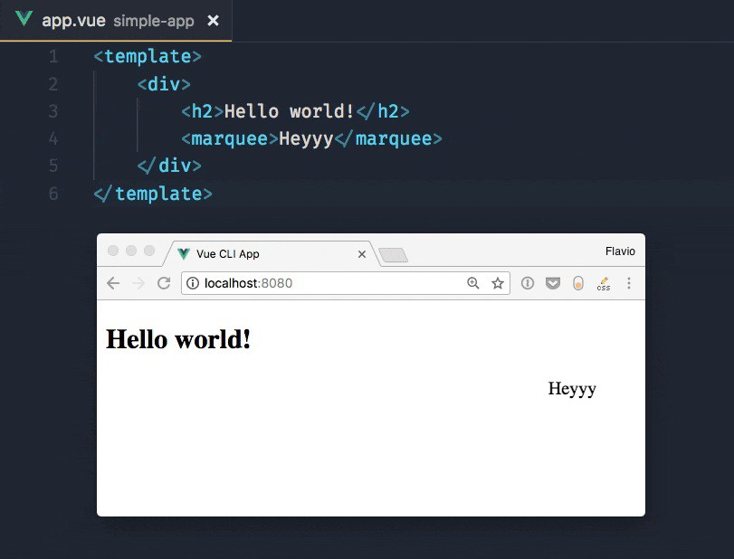

You can serve more organized projects, composed by JavaScript and HTML files as well. Vue CLI by default uses main.js / index.js as its entry point, and you can have a package.json and any tool configuration set up. vue serve will pick it up.

Since this uses global dependencies, it's not an optimal approach for anything more than demonstration or quick testing.

Running vue build will prepare the project for deployment in dist/ , and generate all the corresponding code, also for vendor dependencies.

## Webpack

Internally, Vue CLI uses webpack, but the configuration is abstracted and we don't even see the config file in our folder. You can still have access to it by calling vue inspect :

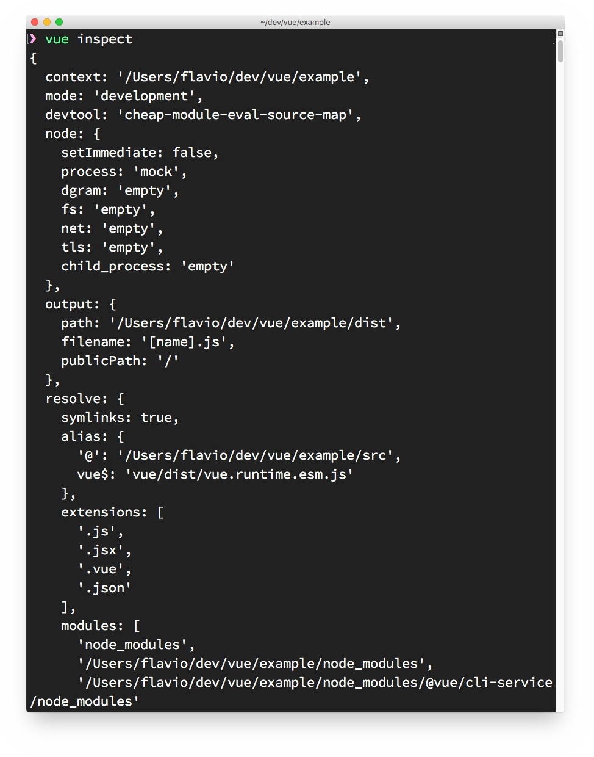

# DevTools

#### Vue has a great panel that integrates into the Browser Developer Tools, which lets you inspect your application and interact with it, to ease debugging and understanding

Install on Chrome Install on Firefox

Install the standalone app

How to use the Developer Tools Filter components

Select component in the page Format components names Filter inspected data

Inspect DOM Open in editor

When you're first experimenting with Vue, if you open the Browser Developer Tools you will find this message: "*Download the Vue Devtools extension for a better development experience:* [*https://github.com/vuejs/vue-devtools*](https://github.com/vuejs/vue-devtools)"

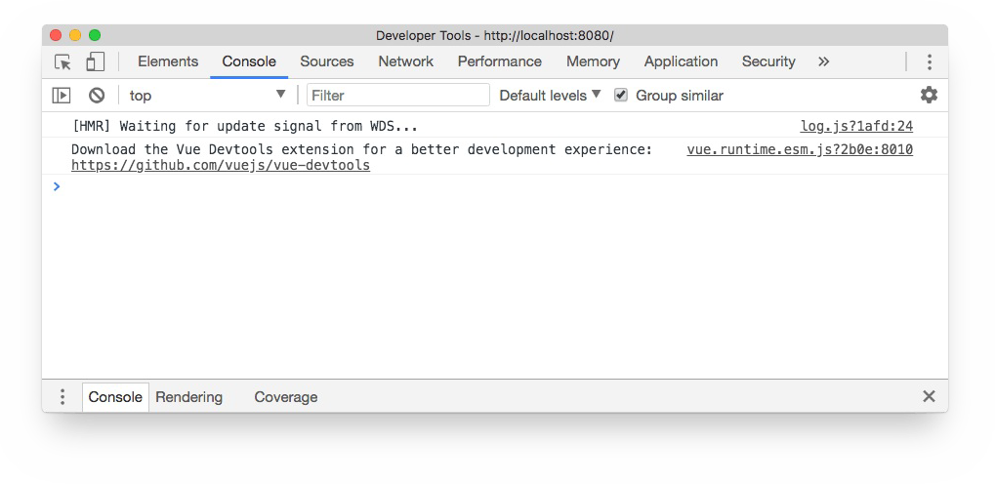

This is a friendly reminder to install the **Vue Devtools Extension**. What's that? Any popular framework has its own devtools extension, which generally adds a new panel to the browser developer tools that is much more specialized than the ones that the browser ships by default. In this case, the panel will let us inspect our Vue application and interact with it.

This tool will be an amazing help when building Vue apps. The developer tools can only inspect a Vue application when it's in development mode. This makes sure no one can use them to interact with your production app (and will make Vue more performant because it does not have to care about the devtools)

Let's install it!

There are 3 ways to install the Vue Dev Tools:

on Chrome on Firefox

as a standalone application

Safari, Edge and other browsers are not supported with a custom extension, but using the standalone application you can debug a Vue.js app running in any browser.

## Install on Chrome

Go to this page on the Google Chrome Store: <https://chrome.google.com/webstore/detail/vuejs-devtools/nhdogjmejiglipccpnnnanhbledajbpd> and click **Add to Chrome**.

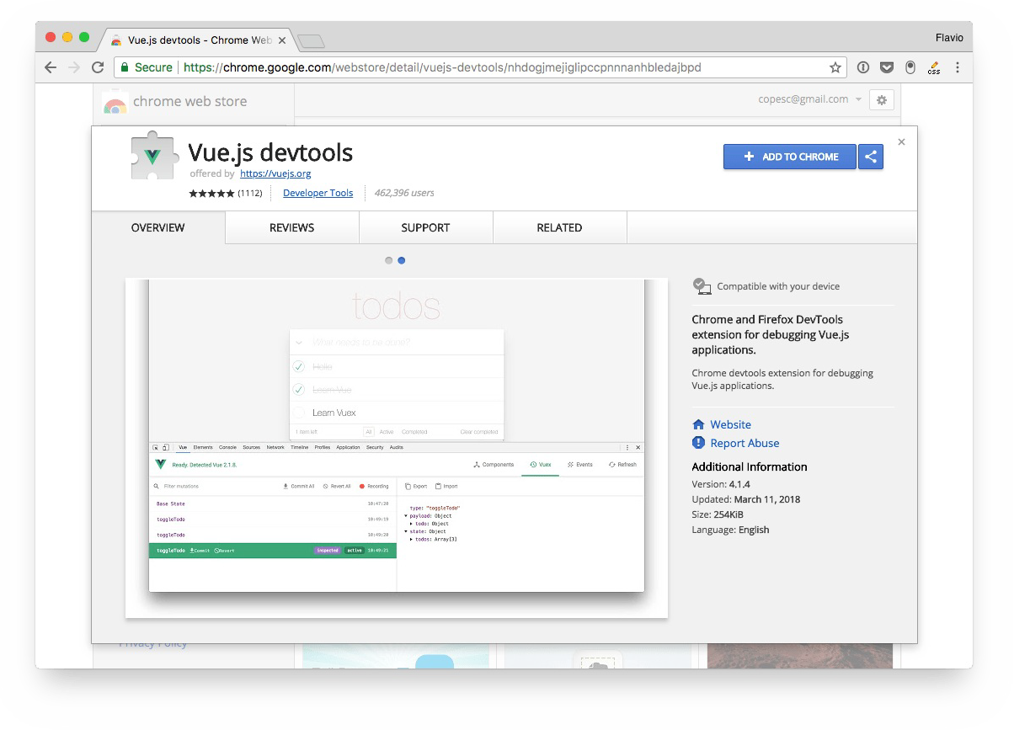

Go through the installation process:

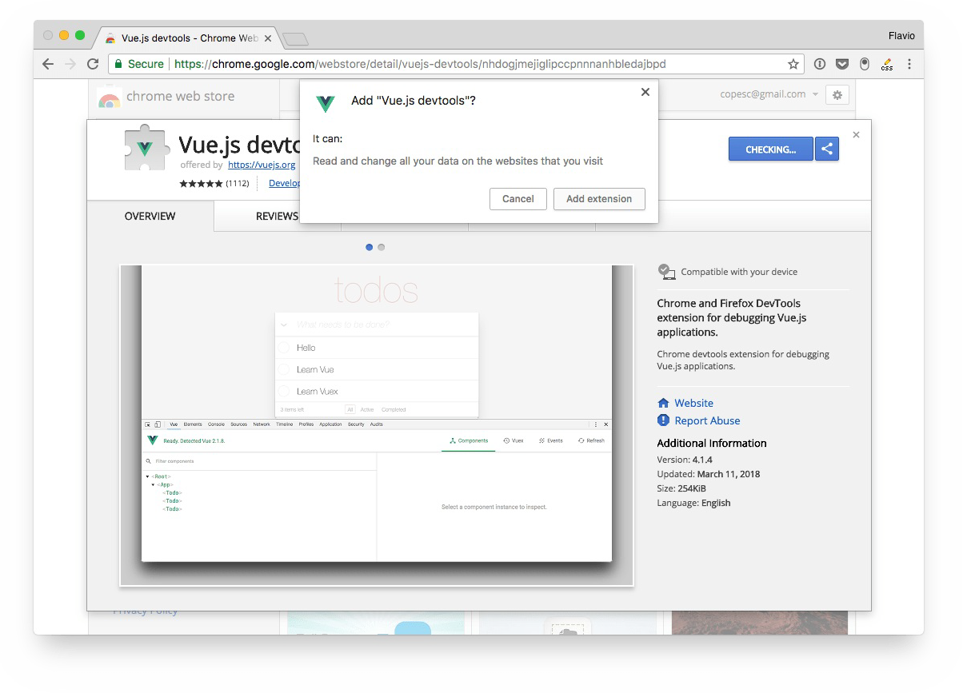

The Vue.js devtools icon shows up in the toolbar. If the page does not have a Vue.js instance running, it's grayed out.

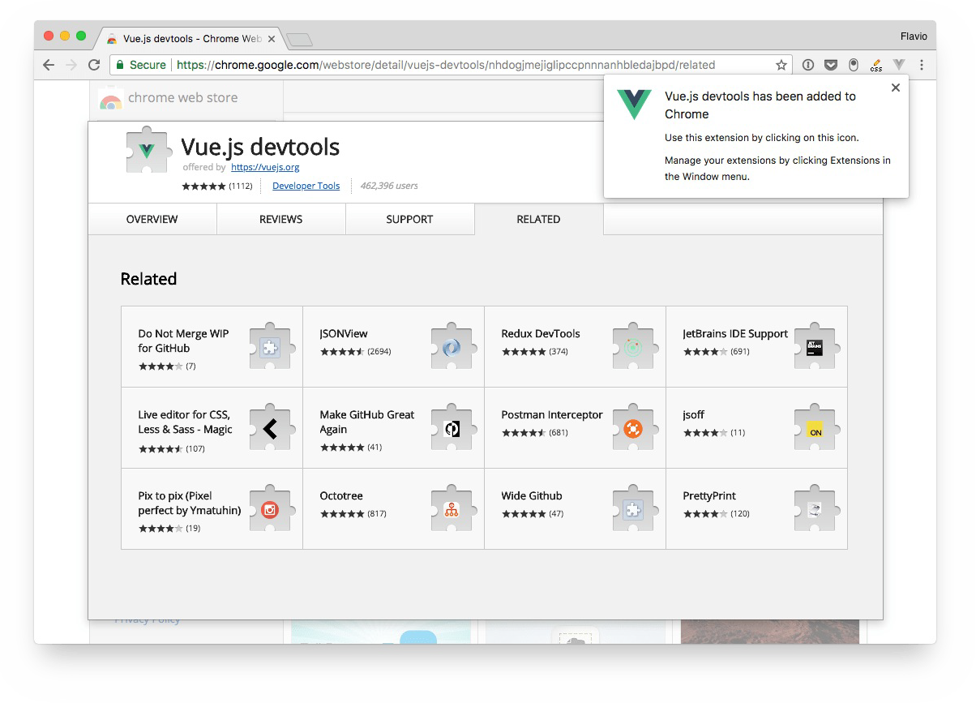

If Vue.js is detected, the icon has the Vue logo colors.

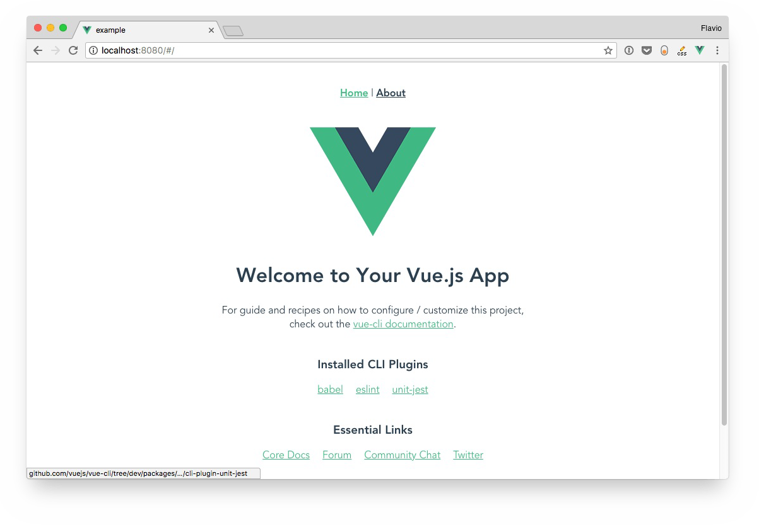

The icon does nothing except showing us that there *is* a Vue.js instance. To use the devtools, we must open the Developer Tools panel, using "View → Developer → Developer Tools", or

Cmd-Alt-i

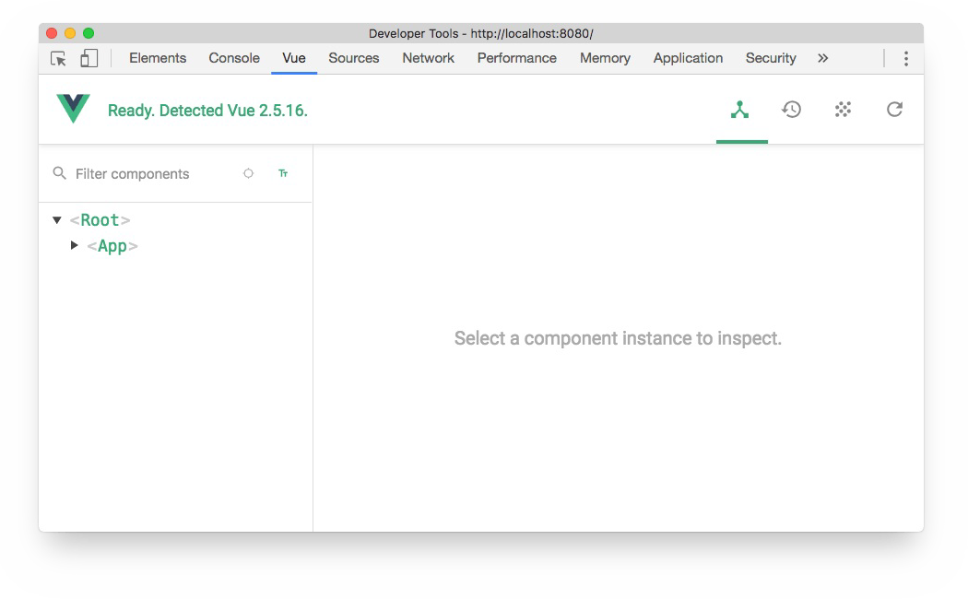

## Install on Firefox

You can find the Firefox dev tools extension in the Mozilla addons store: <https://addons.mozilla.org/en-US/firefox/addon/vue-js-devtools/>

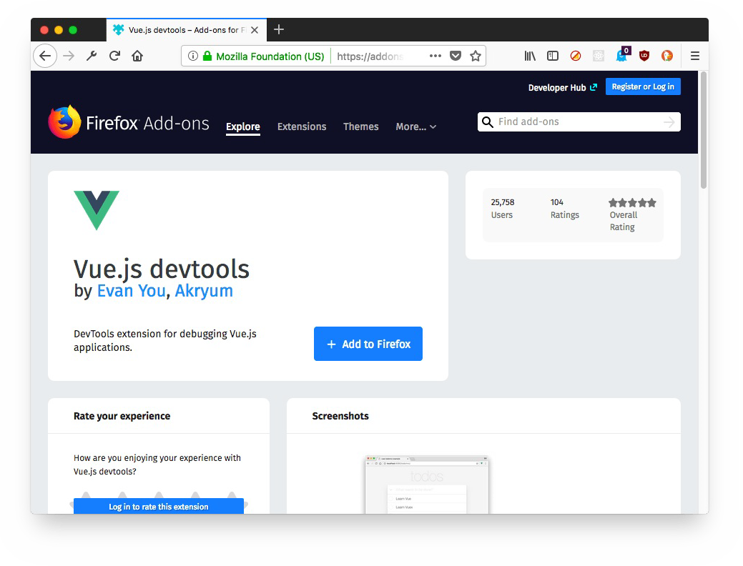

Click "**Add to Firefox**" and the extension will be installed. As with Chrome, a grayed icon shows up in the toolbar

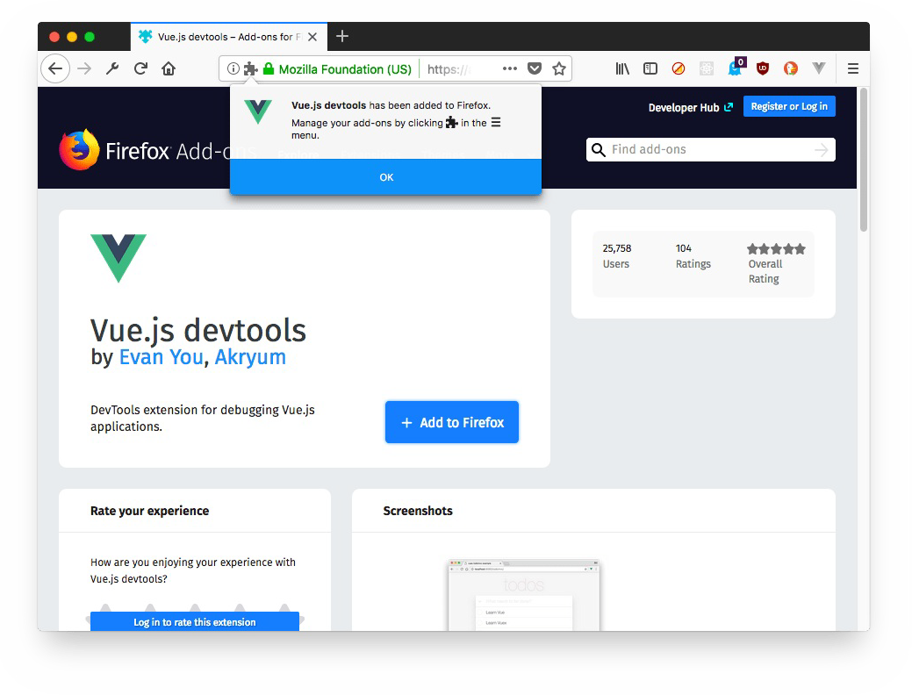

And when you visit a site that has a Vue instance running, it will become green, and when we open the Dev Tools we will see a "**Vue**" panel:

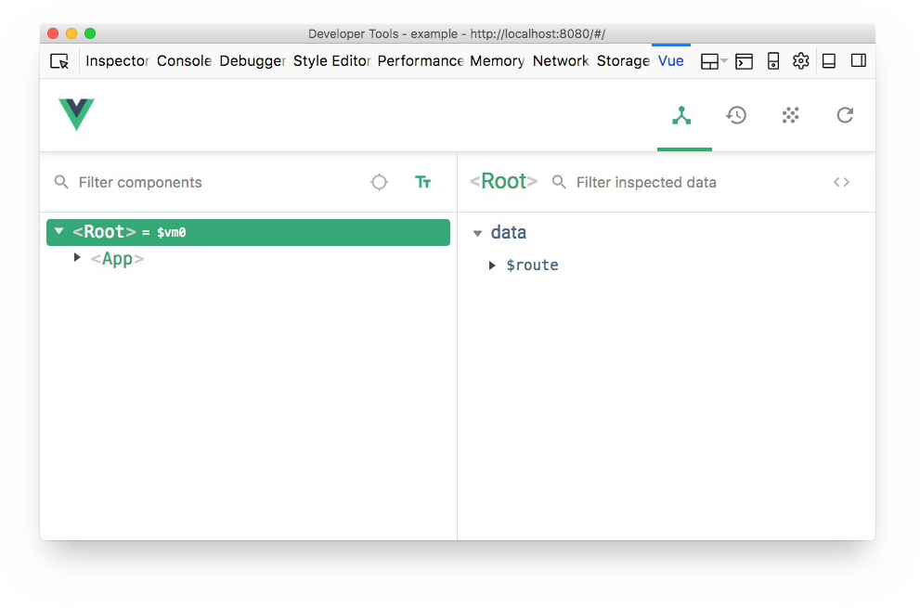

## Install the standalone app

Alternatively, you can use the DevTools standalone app. Simply install it using

npm install -g @vue/devtools

//or

yarn global add @vue/devtools

and run it by calling

vue-devtools

This will open the standalone Electron-based application.

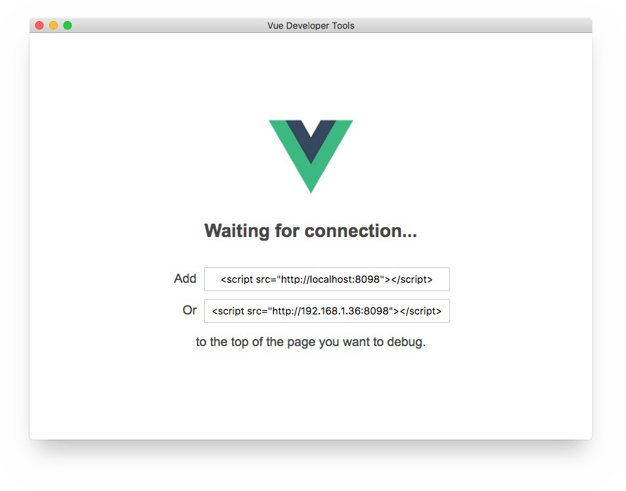

now, paste the script tag it shows you:

<script src="http://localhost:8098"></script>

inside the project index.html file, and wait for the app to be reloaded, and it will automatically connect to the app:

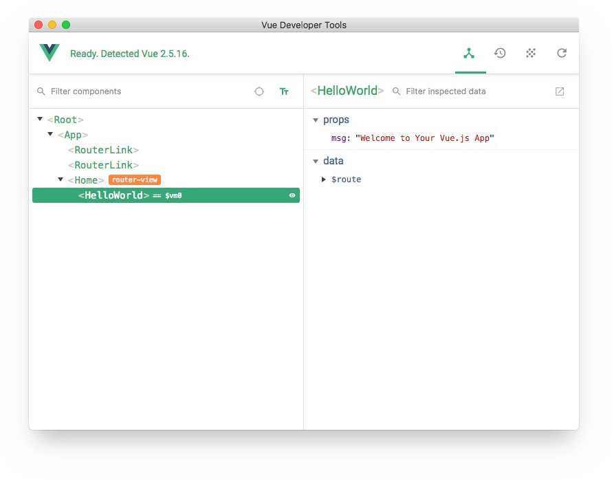

## How to use the Developer Tools

As mentioned, the Vue DevTools can be activated by opening the Developer Tools in the browser and moving to the Vue panel.

Another option is to right-click on any element in the page, and choose "Inspect Vue component":

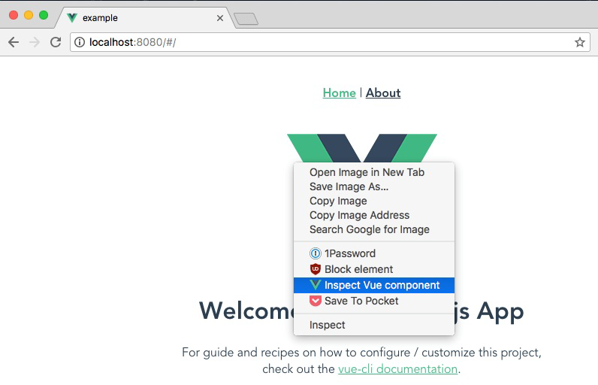

When the Vue DevTools panel is open, we can navigate the components tree. When we choose a component from the list on the left, the right panel shows the props and data it holds:

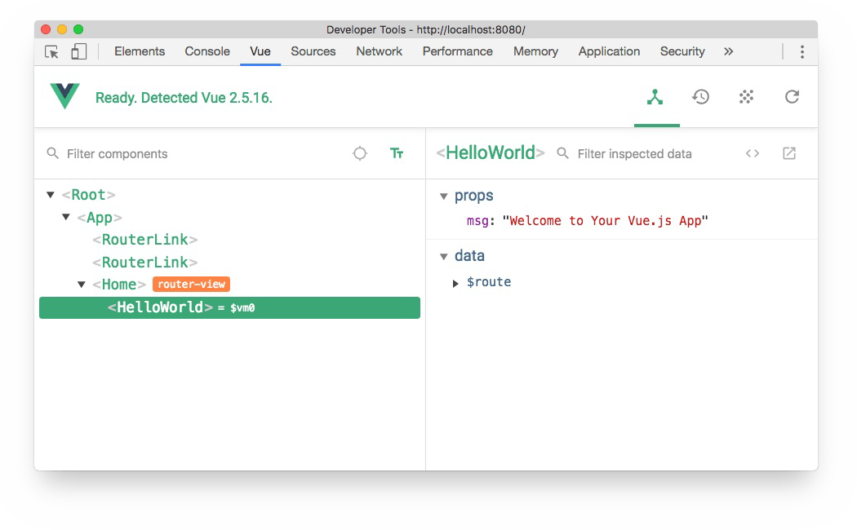

On the top there are 4 buttons:

**Components** (the current panel), which lists all the component instances running in the current page. Vue can have multiple instances running at the same time, for example it

might manage your shopping cart widget and the slideshow, with separate, lightweight apps.

**Vuex** is where you can inspect the state managed through Vuex.

**Events** shows all the events emitted

**Refresh** reloads the devtools panel

Notice the small = $vm0 text beside a component? It's a handy way to inspect a component using the Console. Pressing the "esc" key shows up the console in the bottom of the devtools, and you can type $vm0 to access the Vue component:

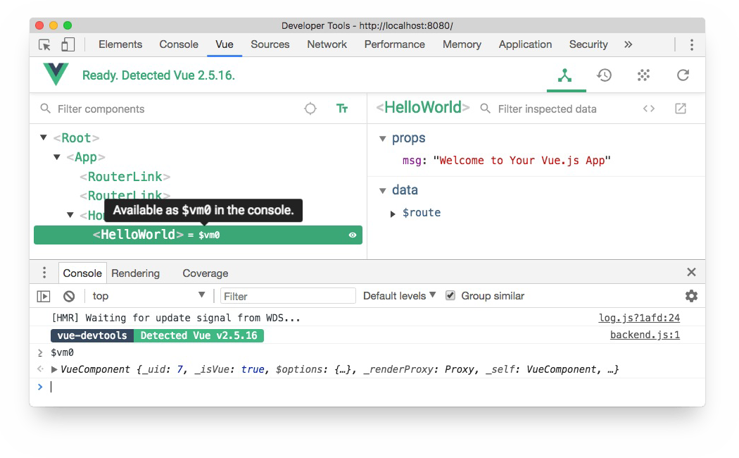

This is very cool to inspect and interact with components without having to assign them to a global variable in the code.

### Filter components

Start typing a component name, and the components tree will filter out the ones that don't match.

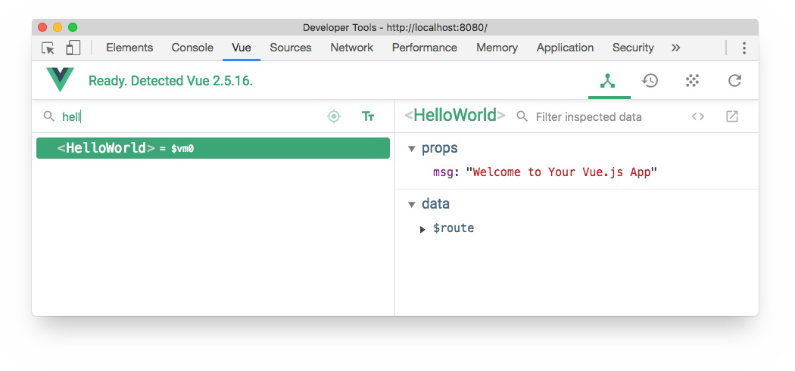

### Select component in the page

Click the



button and you can hover any component in the page with the mouse, click it, and it will be opened in the devtools.

### Format components names

You can choose to show components in camelCase or use dashes.

### Filter inspected data

On the right panel, you can type any word to filter the properties that don't match it.

### Inspect DOM

Click the Inspect DOM button to be brought to the DevTools Elements inspector, with the DOM element generated by the component:

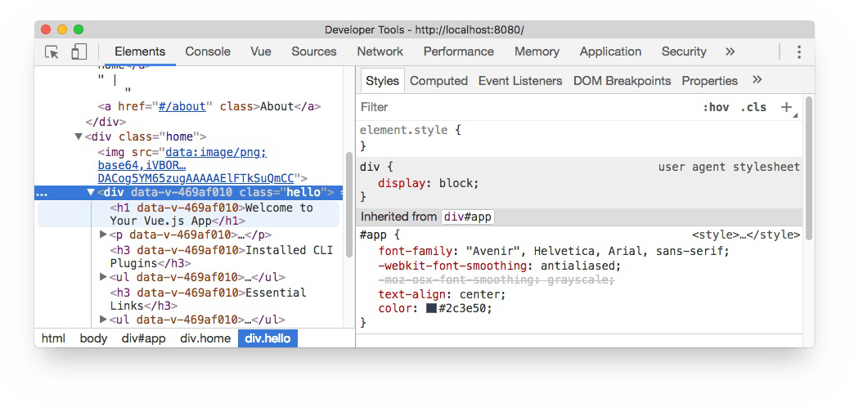

### Open in editor

Any user component (not framework-level components) has a button that opens it in your default editor. Very handy.

# Configuring VS Code for Vue Development

#### Visual Studio Code is one of the most used code editors in the world right now. When you're such a popular editor, people build nice plugins. One of such plugins is an awesome tool that can help us Vue.js developers.

Vetur Installing Vetur

Syntax highlighting Snippets IntelliSense Scaffolding Emmet

Linting and error checking Code Formatting

Visual Studio Code is one of the most used code editors in the world right now. Editors have, like many software products, a cycle. Once TextMate was the favorite by developers, then it was Sublime Text, now it's VS Code.

The cool thing about being popular is that people dedicate a lot of time to building plugins for everything they imagine.

One of such plugins is an awesome tool that can help us Vue.js developers.

## Vetur

[It's called **Vetur**, it's hugely popular, with more than 3 million downloads, and you can find it on the Visual Studio Marketplace.](https://marketplace.visualstudio.com/items?itemName=octref.vetur)

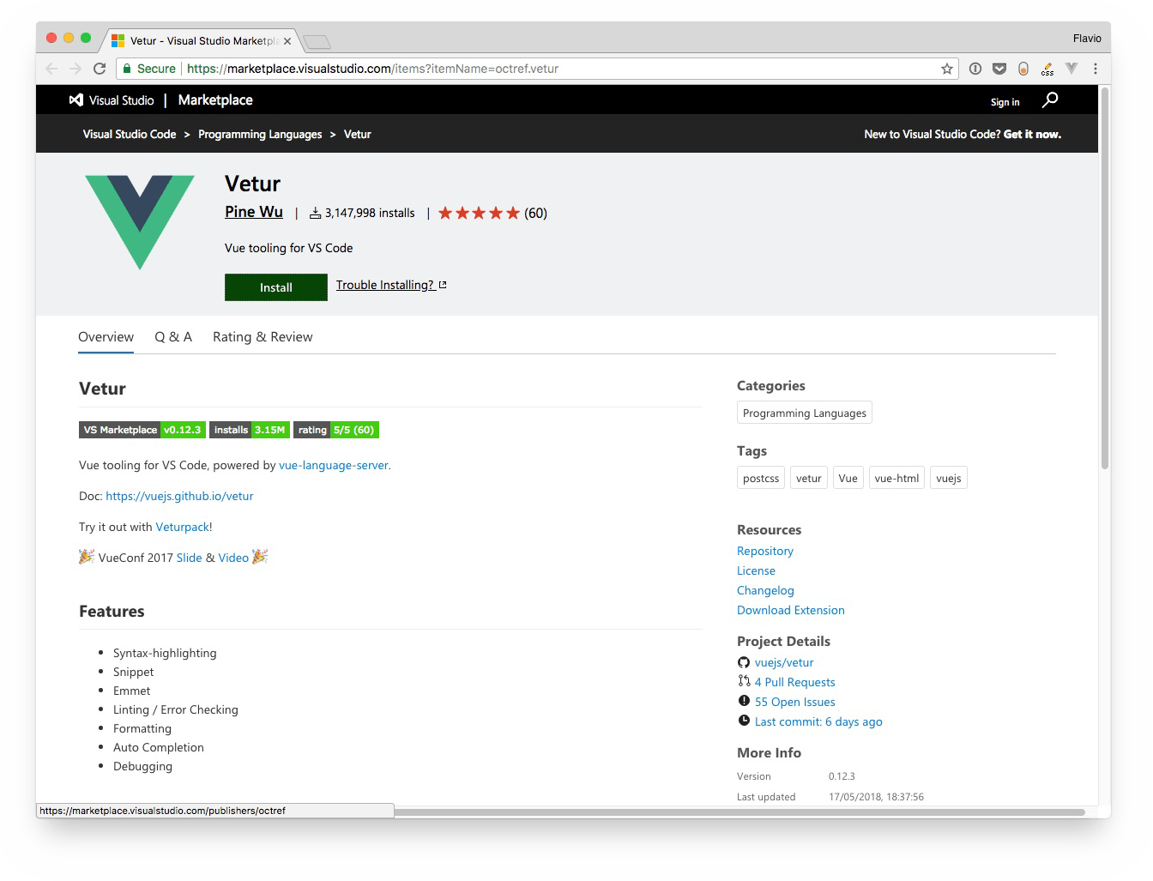

## Installing Vetur

Clicking the Install button will trigger the installation panel in VS Code:

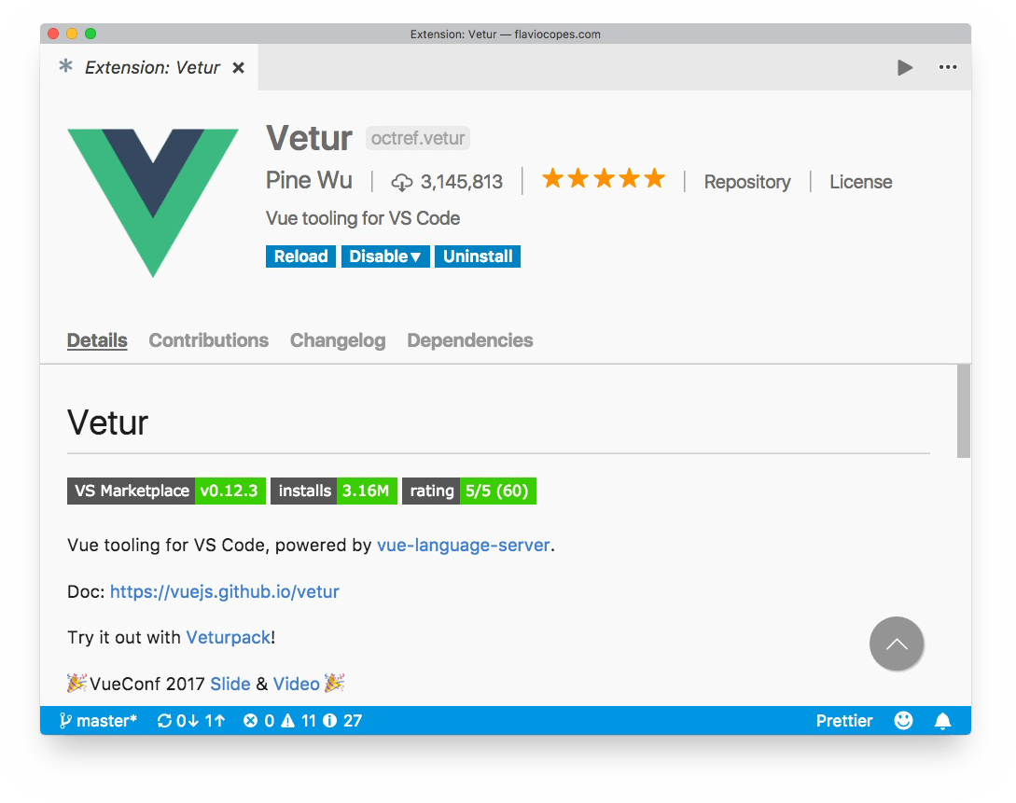

You can also simply open the Extensions in VS Code and search for "vetur":

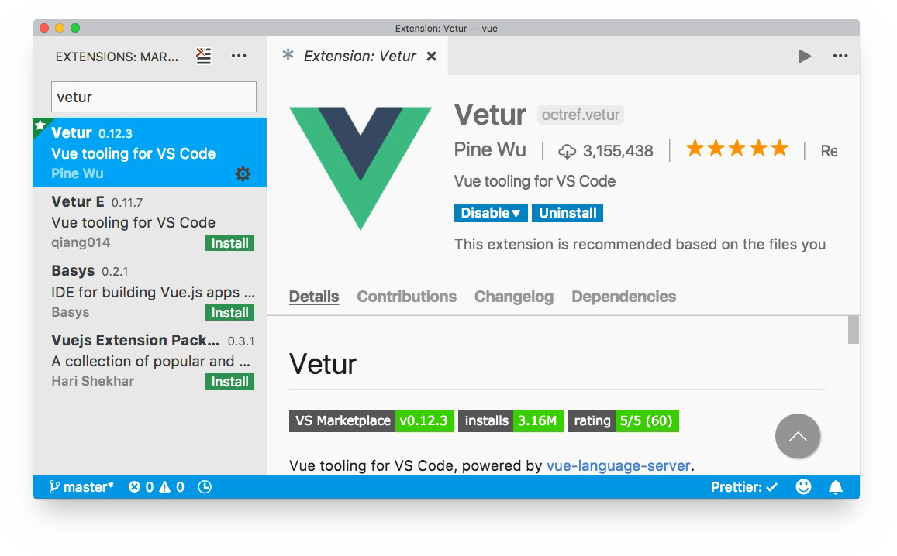

What does this extension provide?

## Syntax highlighting

Vetur provides syntax highlighting for all your Vue source code files. Without Vetur, a .vue file will be displayed in this way by VS Code:

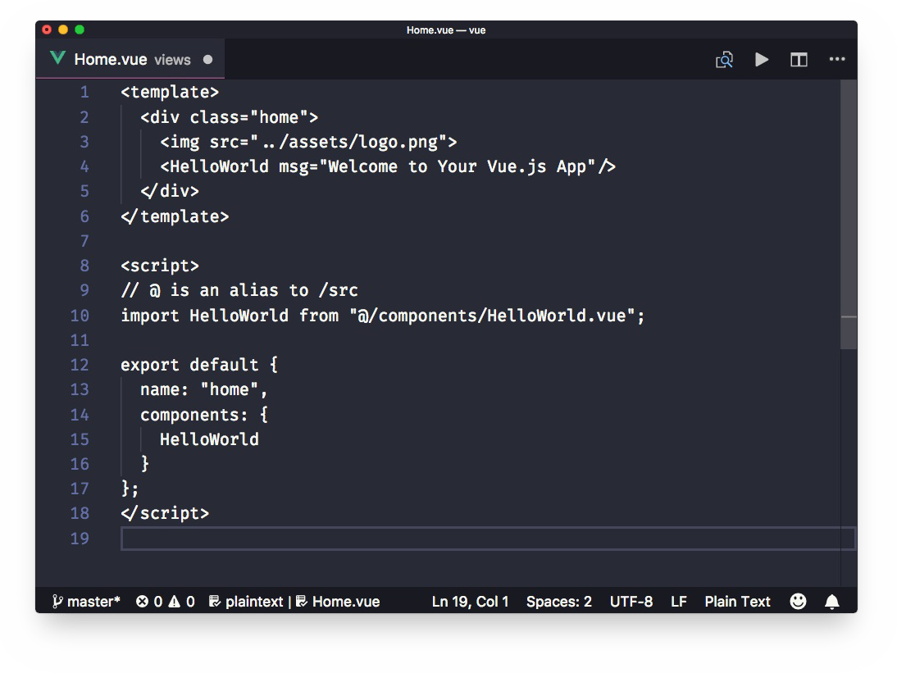

with Vetur installed:

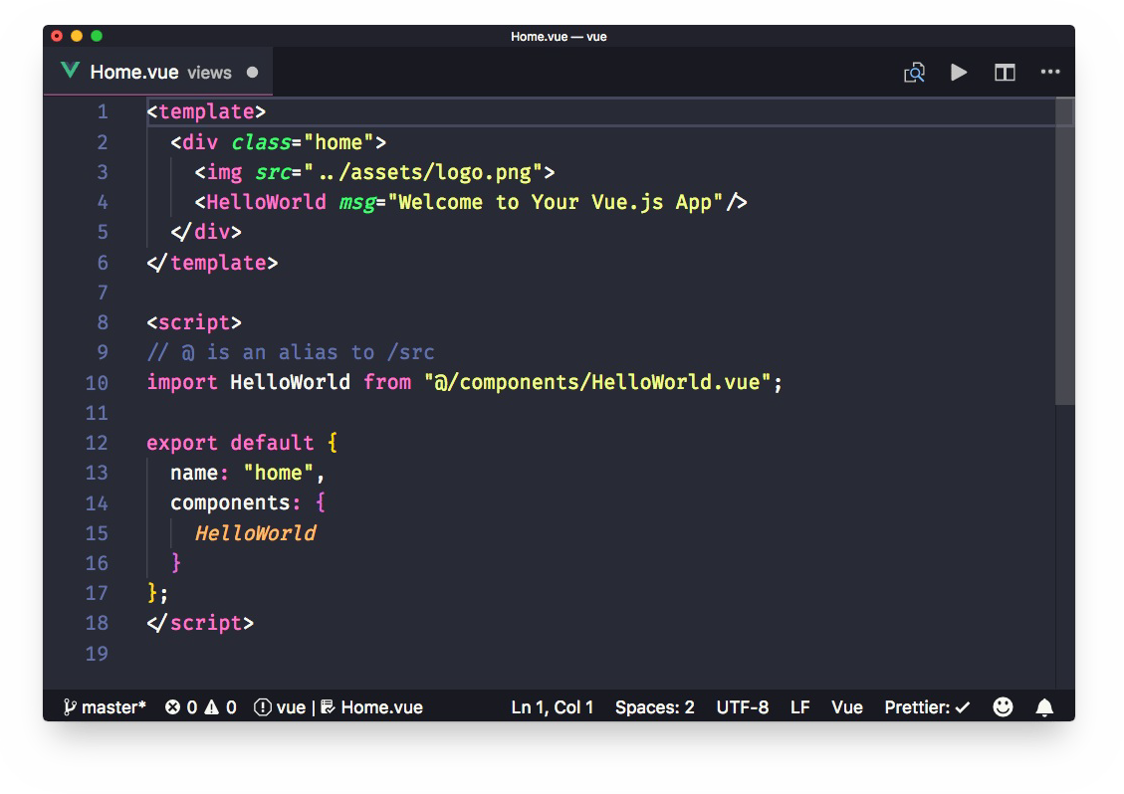

VS Code is able to recognize the type of code contained in a file from its extension.

Using Single File Component, you mix different types of code inside the same file, from CSS to JavaScript to HTML.

VS Code by default cannot recognize this kind of situation, and Vetur allows to provide syntax highlighting for each kind of code you use.

Vetur enables support, among the others, for

HTML CSS

JavaScript Pug

Haml SCSS

PostCSS Sass Stylus TypeScript

## Snippets

As with syntax highlighting, since VS Code cannot determine the kind of code contained in a part of a .vue file, it cannot provide the snippets we all love: pieces of code we can add to the file, provided by specialized plugins.

Vetur provides VS Code the ability to use your favorite snippets in Single File Components.

## IntelliSense

IntelliSense is also enabled bye Vetur, for each different language, with autocomplete:

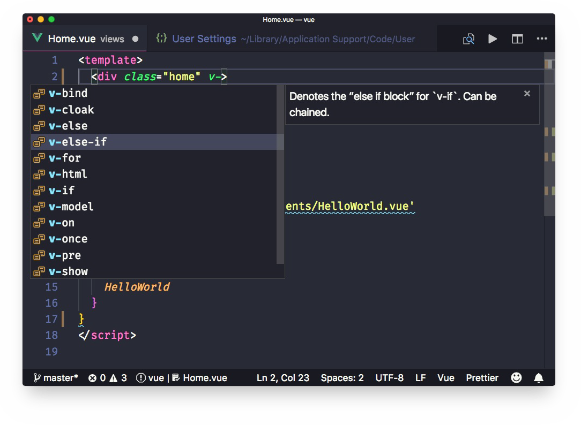

## Scaffolding

In addition to enabling custom snippets, Vetur provides its own set of snippets. Each one creates a specific tag (template, script or style) with its own language:

scaffold

template with html

template with pug

script with JavaScript

script with TypeScript

style with CSS

style with CSS (scoped)

style with scss

style with scss (scoped)

style with less

style with less (scoped)

style with sass

style with sass (scoped)

style with postcss

style with postcss (scoped)

style with stylus

style with stylus (scoped)

If you type scaffold , you'll get a starter pack for a single-file component:

<template>

</template>

<script>

export default {

}

</script>

<style>

</style>

the others are specific and create a single block of code.

Note: (scoped) means that it applies to the current component only

## Emmet

Emmet, the popular HTML/CSS abbreviations engine, is supported by default. You can type one of the Emmet abbreviations and by pressing tab VS Code will automatically expand it to the HTML equivalent:

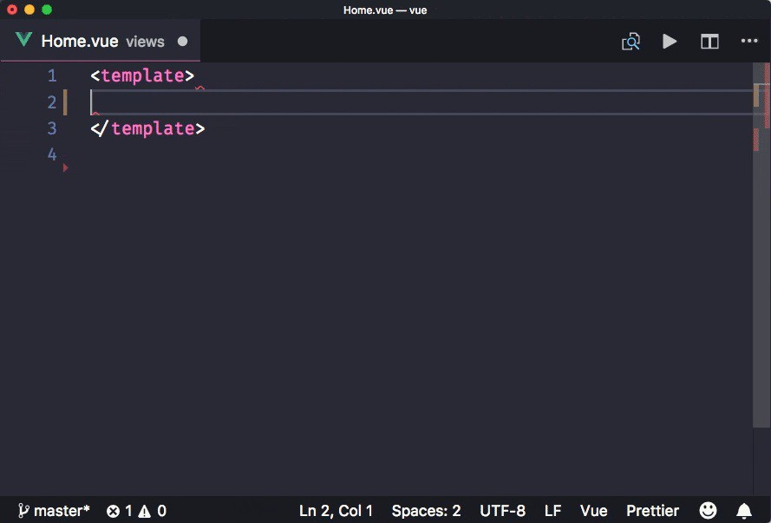

## Linting and error checking

Vetur integrates with ESLint, through the [VS Code ESLint plugin](https://marketplace.visualstudio.com/items?itemName=dbaeumer.vscode-eslint).

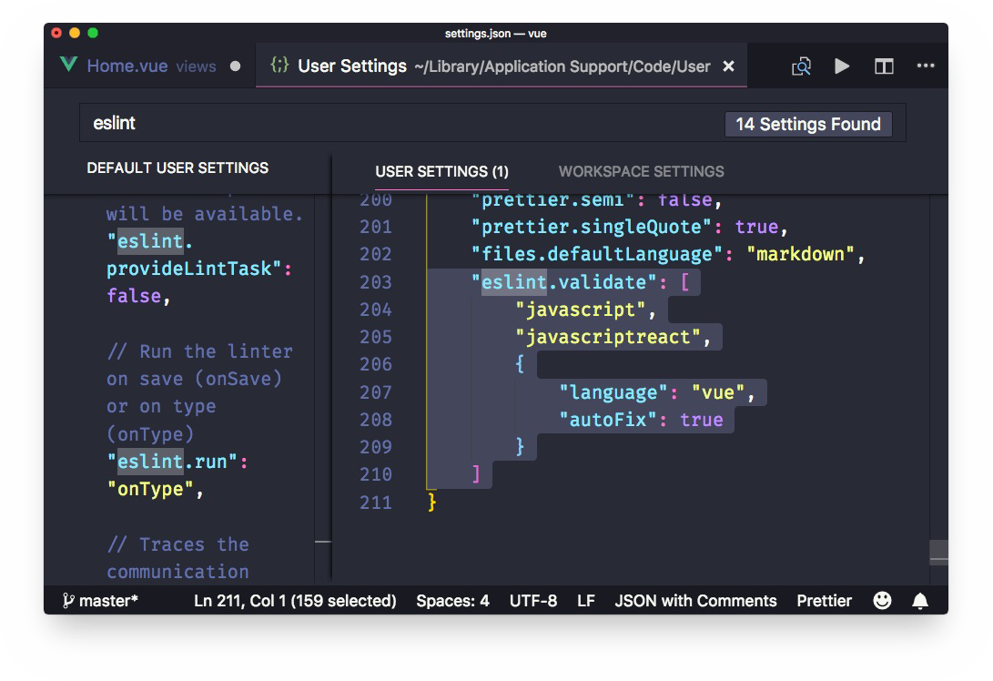

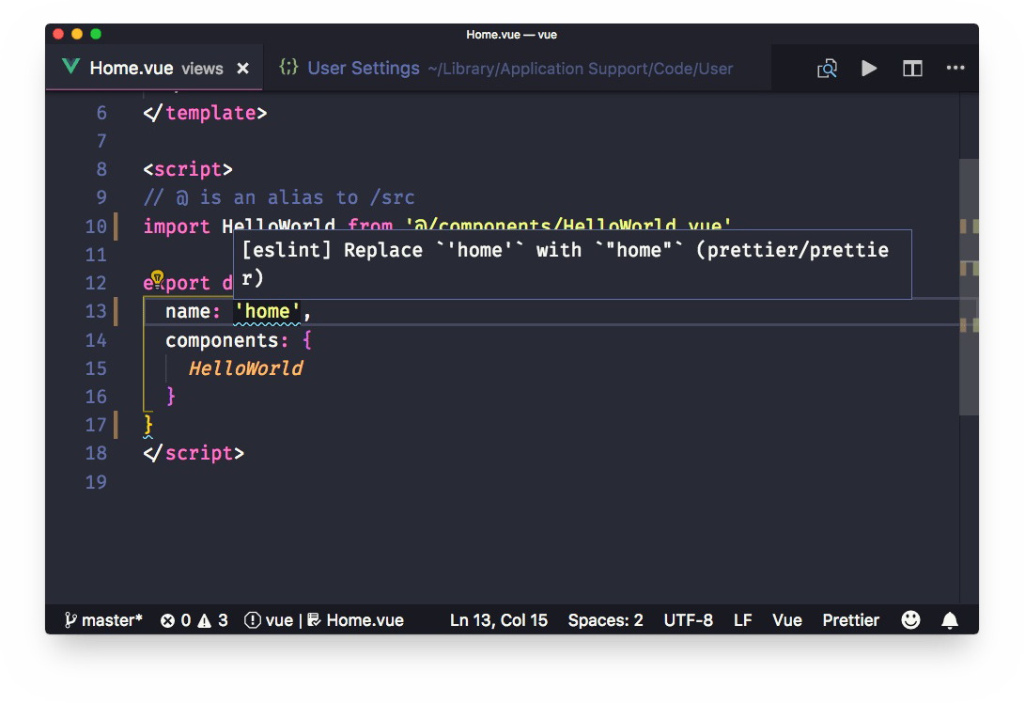

## Code Formatting

Vetur provides automatic support for code formatting, to format the whole file upon save (in combination with the "editor.formatOnSave" VS Code setting.

You can choose to disable automatic formatting for some specific language by setting the

vetur.format.defaultFormatter.XXXXX to none in the VS Code settings. To change one of those settings, just start searching for the string, and override what you want in the user settings (the right panel).

Most of the languages supported use Prettier for automatic formatting, a tool that's becoming an industry standard.

Uses your Prettier configuration to determine your preferences.

# Components

Components are single, independent units of an interface. They can have their own state, markup and style.

## How to use components

Vue components can be defined in 4 main ways. Let's talk in code.

The first is:

new Vue({

/* options */

})

The second is:

Vue.component('component-name', {

/* options */

})

The third is by using local components: components that only accessible by a specific component, and not available elsewhere (great for encapsulation).

The fourth is in .vue files, also called Single File Components. Let's dive into the first 3 ways in details.

Using new Vue() or Vue.component() is the standard way to use Vue when you're building an application that is not a Single Page Application (SPA) but rather uses Vue.js just in some pages, like in a contact form or in the shopping cart. Or maybe Vue is used in all pages, but the server is rendering the layout, and you serve the HTML to the client, which then loads the Vue application you build.

In an SPA, where it's Vue that builds the HTML, it's more common to use Single File Components as they are more convenient.

You instantiate Vue by mounting it on a DOM element. If you have a <div id="app"></div>

tag, you will use:

new Vue({ el: '#app' })

A component initialized with new Vue has no corresponding tag name, so it's usually the main container component.

Other components used in the application are initialized using Vue.component() . Such a component allows you to define a tag, with which you can embed the component multiple times in the application, and specify the output of the component in the template property:

<div id="app">

<user-name name="Flavio"></user-name>

</div>

Vue.component('user-name', { props: ['name'],

template: '<p>Hi {{ name }}</p>'

})

new Vue({ el: '#app'

})

What are we doing? We are initializing a Vue root component on #app , and inside that, we use the Vue component user-name , which abstracts our greeting to the user.

The component accepts a prop, which is an attribute we use to pass data down to child components.

In the Vue.component() call we passed user-name as the first parameter. This gives the component a name. You can write the name in 2 ways here. The first is the one we used, called **kebab-case**. The second is called **PascalCase**, which is like camelCase, but with the first letter capitalized:

Vue.component('UserName', {

/* ... */

})

Vue internally automatically creates an alias from user-name to UserName , and vice versa, so you can use whatever you like. It's generally best to use UserName in the JavaScript, and

user-name in the template.

## Local components

Any component created using Vue.component() is **globally registered**. You don't need to assign it to a variable or pass it around to reuse it in your templates.

You can encapsulate components locally by assigning an object that defines the component object to a variable:

const Sidebar = {

template: '<aside>Sidebar</aside>'

}

and then make it available inside another component by using the components property:

new Vue({ el: '#app',

components: { Sidebar

}

})

You can write the component in the same file, but a great way to do this is to use JavaScript modules:

import Sidebar from './Sidebar'

export default { el: '#app', components: {

Sidebar

}

}

## Reusing a component

A child component can be added multiple times. Each separate instance is independent of the others:

<div id="app">

<user-name name="Flavio"></user-name>

<user-name name="Roger"></user-name>

<user-name name="Syd"></user-name>

</div>

Vue.component('user-name', { props: ['name'],

template: '<p>Hi {{ name }}</p>'

})

new Vue({ el: '#app'

})

## The building blocks of a component

So far we've seen how a component can accept the , props and template properties.

el

el is only used in root components initialized using new Vue({}) , and identifies the DOM element the component will mount on.

props lists all the properties that we can pass down to a child component

template is where we can set up the component template, which will be responsible for defining the output the component generates.

A component accepts other properties:

data the component local state

methods : the component methods

computed : the computed properties associated with the component

watch : the component watchers

# Single File Components

#### Learn how Vue helps you create a single file that is responsible for everything that regards a single component, centralizing the responsibility for the appearance and behavior

A Vue component can be declared in a JavaScript file ( .js ) like this:

Vue.component('component-name', {

/* options */

})

or also:

new Vue({

/* options */

})

or it can be specified in a .vue file.

The .vue file is pretty cool because it allows you to define

JavaScript logic HTML code template CSS styling

all in just a single file, and as such it got the name of **Single File Component**.

Here's an example:

<template>

<p>{{ hello }}</p>

</template>

<script>

export default { data() {

return {

hello: 'Hello World!'

}

}

}

</script>

<style scoped> p {

color: blue;

}

</style>

All of this is possible thanks to the use of webpack. The Vue CLI makes this very easy and supported out of the box. .vue files cannot be used without a webpack setup, and as such, they are not very suited to apps that just use Vue on a page without being a full-blown single- page app (SPA).

Since Single File Components rely on Webpack, we get for free the ability to use modern Web features.

Your CSS can be defined using SCSS or Stylus, the template can be built using Pug, and all you need to do to make this happen is to declare to Vue which language preprocessor you are going to use.

The list of supported preprocessors include

TypeScript SCSS

Sass Less PostCSS Pug

We can use modern JavaScript (ES6-7-8) regardless of the target browser, using the Babel integration, and ES Modules too, so we can use import/export statements.

We can use CSS Modules to scope our CSS.

Speaking of scoping CSS, Single File Components make it absolutely easy to write CSS that won't *leak* to other components, by using <style scoped> tags.

If you omit scoped , the CSS you define will be global. But adding that, Vue adds automatically a specific class to the component, unique to your app, so the CSS is guaranteed to not leak out to other components.

Maybe your JavaScript is huge because of some logic you need to take care of. What if you want to use a separate file for your JavaScript?

You can use the src attribute to externalize it:

<template>

<p>{{ hello }}</p>

</template>

<script src="./hello.js"></script>

This also works for your CSS:

<template>

<p>{{ hello }}</p>

</template>

<script src="./hello.js"></script>

<style src="./hello.css"></style>

Notice how I used

export default { data() {

return {

hello: 'Hello World!'

}

}

}

in the component's JavaScript to set up the data.

Other common ways you will see are

export default { data: function() {

return {

name: 'Flavio'

}

}

}

(the above is equivalent to what we did before)

or:

export default { data: () => {

return {

name: 'Flavio'

}

}

}

this is different because it uses an arrow function. Arrow functions are fine until we need to access a component method, as we need to make use of this and such property is not bound to the component using arrow functions. So it's mandatory to use *regular* functions rather than arrow functions.

You might also see

module.exports = {

data: () => { return {

name: 'Flavio'

}

}

}

this is using the CommonJS syntax, and works as well, although it's recommended to use the ES Modules syntax, as that is a JavaScript standard.

# Templates

#### Vue.js uses a templating language that's a superset of HTML. Any HTML is a valid Vue.js template, and in addition to that, Vue.js provides two powerful things: interpolation and directives.

Vue.js uses a templating language that's a superset of HTML.

Any HTML is a valid Vue.js template, and in addition to that, Vue.js provides two powerful things: **interpolation** and **directives**.

I'm going to detail interpolation in this article, and make a new one tomorrow for directives.

This is a valid Vue.js template:

<span>Hello!</span>

This template can be put inside a Vue component declared explicitly:

new Vue({

template: '<span>Hello!</span>'

})

or it can be put into a Single File Component:

<template>

<span>Hello!</span>

</template>

This first example is very basic. The next step is making it output a piece of the component state, for example, a name.

This can be done using interpolation. First, we add some data to our component:

new Vue({ data: {

name: 'Flavio'

},

template: '<span>Hello!</span>'

})

and then we can add it to our template using the double brackets syntax:

new Vue({ data: {

name: 'Flavio'

},

template: '<span>Hello {{name}}!</span>'

})

One interesting thing here. See how we just used name instead of this.data.name ?

This is because Vue.js does some internal binding and lets the template use the property as if it was local. Pretty handy.

In a single file component, that would be:

<template>

<span>Hello {{name}}!</span>

</template>

<script>

export default { data() {

return {

name: 'Flavio'

}

}

}

</script>

I used a regular function in my export. Why not an arrow function?

This is because in data we might need to access a method in our component instance, and we can't do that if this is not bound to the component, so arrow functions usage is not possible.

We could use an arrow function, but then I would need to remember to switch to a regular function in case I use this . Better play it safe, I think.

Now, back to the interpolation.

{{ name }} reminds of Mustache / Handlebars template interpolation, but it's just a visual reminder.

While in those templating engines they are "dumb", in Vue, you can do much more, it's more flexible.

You can use **any JavaScript expression** inside your interpolations, but you're limited to just one expression:

{{ name.reverse() }}

{{ name === 'Flavio' ? 'Flavio' : 'stranger' }}

Vue provides access to some global objects inside templates, including Math and Date, so you can use them:

{{ Math.sqrt(16) * Math.random() }}

It's best to avoid adding complex logic to templates, but the fact Vue allows it gives us more flexibility, especially when trying things out.

We can first try to put an expression in the template, and then move it to a computed property or method later on.

The value included in any interpolation will be updated upon a change of any of the data properties it relies on.

You can avoid this reactivity by using the v-once directive.

The result is always escaped, so you can't have HTML in the output.

If you need to have an HTML snippet you need to use the v-html directive instead.

# Styling components using CSS

#### Learn all the options at your disposal to style Vue.js components using CSS

Note: this tutorial uses Vue.js Single File Components

The simplest option to add CSS to a Vue.js component is to use the style tag, just like in HTML:

<template>

<p style="text-decoration: underline">Hi!</p>

</template>

<script>

export default { data() {

return {

decoration: 'underline'

}

}

}

</script>

This is as much static as you can get. What if you want underline to be defined in the component data? Here's how you can do it:

<template>

<p :style="{'text-decoration': decoration}">Hi!</p>

</template>

<script>

export default { data() {

return {

decoration: 'underline'

}

}

}

</script>

:style is a shorthand for v-bind:style . I'll use this shorthand throughout this tutorial.

Notice how we had to wrap text-decoration in quotes. This is because of the dash, which is not part of a valid JavaScript identifier.

You can avoid the quote by using a special camelCase syntax that Vue.js enables, and rewriting it to textDecoration :

<template>

<p :style="{textDecoration: decoration}">Hi!</p>

</template>

Instead of binding an object to style , you can reference a computed property:

<template>

<p :style="styling">Hi!</p>

</template>

<script>

export default { data() {

return {

textDecoration: 'underline', textWeight: 'bold'

}

},

computed: {

styling: function() { return {

textDecoration: this.textDecoration, textWeight: this.textWeight

}

}

}

}

</script>

Vue components generate plain HTML, so you can choose to add a class to each element, and add a corresponding CSS selector with properties that style it:

<template>

<p class="underline">Hi!</p>

</template>

<style>

.underline { text-decoration: underline; }

</style>

You can use SCSS like this:

<template>

<p class="underline">Hi!</p>

</template>

<style lang="scss"> body {

.underline { text-decoration: underline; }

}

</style>

You can hardcode the class like in the above example, or you can bind the class to a component property, to make it dynamic, and only apply to that class if the data property is true:

<template>

<p :class="{underline: isUnderlined}">Hi!</p>

</template>

<script>

export default { data() {

return { isUnderlined: true

}

}

}

</script>

<style>

.underline { text-decoration: underline; }

</style>

Instead of binding an object to class, like we did with <p :class="{text: isText}">Hi!</p> , you can directly bind a string, and that will reference a data property:

<template>

<p :class="paragraphClass">Hi!</p>

</template>

<script>

export default { data() {

return {

paragraphClass: 'underline'

}

}

}

</script>

<style>

.underline { text-decoration: underline; }

</style>

You can assign multiple classes either adding two classes to paragraphClass in this case or by using an array:

<template>

<p :class="[decoration, weight]">Hi!</p>

</template>

<script>

export default { data() {

return {

decoration: 'underline', weight: 'weight',

}

}

}

</script>

<style>

.underline { text-decoration: underline; }

.weight { font-weight: bold; }

</style>

The same can be done using an object inlined in the class binding:

<template>

<p :class="{underline: isUnderlined, weight: isBold}">Hi!</p>

</template>

<script>

export default { data() {

return { isUnderlined: true, isBold: true

}

}

}

</script>

<style>

.underline { text-decoration: underline; }

.weight { font-weight: bold; }

</style>

And you can combine the two statements:

<template>

<p :class="[decoration, {weight: isBold}]">Hi!</p>

</template>

<script>

export default { data() {

return {

decoration: 'underline', isBold: true

}

}

}

</script>

<style>

.underline { text-decoration: underline; }

.weight { font-weight: bold; }

</style>

You can also use a computed property that returns an object, which works best when you have many CSS classes to add to the same element:

<template>

<p :class="paragraphClasses">Hi!</p>

</template>

<script>

export default { data() {

return { isUnderlined: true, isBold: true

}

},

computed: {

paragraphClasses: function() { return {

underlined: this.isUnderlined, bold: this.isBold

}

}

}

}

</script>

<style>

.underlined { text-decoration: underline; }

.bold { font-weight: bold; }

</style>

Notice that in the computed property you need to reference the component data using this. [propertyName] , while in the template data properties are conveniently put as first-level properties.

Any CSS that's not hardcoded like in the first example is going to be processed by Vue, and Vue does the nice job of automatically prefixing the CSS for us, so we can write clean CSS while still targeting older browsers (which still means browsers that Vue supports, so IE9+)

# Directives

#### Vue.js uses a templating language that's a superset of HTML. We can use interpolation, and directives. This article explains directives.

v-text

v-once

v-html

v-bind

Two-way binding using v-model

Using expressions Conditionals Loops

Events Show or hide

Event directive modifiers Custom directives

We saw in Vue.js templates and interpolations how you can embed data in Vue templates. This article explains the other technique offered by Vue.js in templates: **directives**.

Directives, are basically like HTML attributes which are added inside templates. They all start with v- , to indicate that's a Vue special attribute.

Let's see each of the Vue directives in details.

**v-text**

Instead of using interpolation, you can use the v-text directive. It performs the same job:

<span v-text="name"></span>

**v-once**

You know how {{ name }} binds to the name property of the component data.

Any time name changes in your component data, Vue is going to update the value represented in the browser.

Unless you use the v-once directive, which is basically like an HTML attribute:

<span v-once>{{ name }}</span>

**v-html**

When you use interpolation to print a data property, the HTML is escaped. This is a great way that Vue uses to automatically protect from XSS attacks.

There are cases however where you want to output HTML and make the browser interpret it. You can use the v-html directive:

<span v-html="someHtml"></span>

**v-bind**

Interpolation only works in the tag content. You can't use it on attributes. Attributes must use v-bind :

<a v-bind:href="url">{{ linkText }}</a>

v-bind is so common that there is a shorthand syntax for it:

<a v-bind:href="url">{{ linkText }}</a>

<a :href="url">{{ linkText }}</a>

**Two-way binding using v-model**

v-model lets us bind a form input element for example, and make it change the Vue data property when the user changes the content of the field:

<input v-model="message" placeholder="Enter a message">

<p>Message is: {{ message }}</p>

<select v-model="selected">

<option disabled value="">Choose a fruit</option>

<option>Apple</option>

<option>Banana</option>

<option>Strawberry</option>

</select>

<span>Fruit chosen: {{ selected }}</span>

## Using expressions

You can use any JavaScript expression inside a directive:

<span v-text="'Hi, ' + name + '!'"></span>

<a v-bind:href="'https://' + domain + path">{{ linkText }}</a>

Any variable used in a directive references the corresponding data property.

## Conditionals

Inside a directive you can use the ternary operator to perform a conditional check, since that's an expression:

<span v-text="name == Flavio ? 'Hi Flavio!' : 'Hi' + name + '!'"></span>

There are dedicated directives that allow you to perform more organized conditionals: v-if ,

v-else and v-else-if .

<p v-if="shouldShowThis">Hey!</p>

shouldShowThis is a boolean value contained in the component's data.

## Loops

v-for allows you to render a list of items. Use it in combination with v-bind to set the properties of each item in the list.

You can iterate on a simple array of values:

<template>

<ul>

<li v-for="item in items">{{ item }}</li>

</ul>

</template>

<script>

export default { data() {

return {

items: ['car', 'bike', 'dog']

}

}

}

</script>

Or on an array of objects:

<template>

<div>

<!-- using interpolation -->

<ul>

<li v-for="todo in todos">{{ todo.title }}</li>

</ul>

<!-- using v-text -->

<ul>

<li v-for="todo in todos" v-text="todo.title"></li>

</ul>

</div>

</template>

<script>

export default { data() {

return { todos: [

{ id: 1, title: 'Do something' },

{ id: 2, title: 'Do something else' }

]

}

}

}

</script>

v-for can give you the index using:

<li v-for="(todo, index) in todos"></li>

## Events

v-on allows you to listen to DOM events, and trigger a method when the event happens. Here we listen for a click event:

<template>

<a v-on:click="handleClick">Click me!</a>

</template>

<script>

export default { methods: {

handleClick: function() { alert('test')

}

}

}

</script>

You can pass parameters to any event:

<template>

<a v-on:click="handleClick('test')">Click me!</a>

</template>

<script>

export default { methods: {

handleClick: function(value) { alert(value)

}

}

}

</script>

and small bits of JavaScript (a single expression) can be put directly into the template:

<template>

<a v-on:click="counter = counter + 1">{{counter}}</a>

</template>

<script>

export default { data: function() {

return { counter: 0

}

}

}

</script>

click is just one kind of event. A common event is submit , which you can bind using v- on:submit .

v-on is so common that there is a shorthand syntax for it, @ :

<a v-on:click="handleClick">Click me!</a>

<a @:click="handleClick">Click me!</a>

## Show or hide

You can choose to only show an element in the DOM if a particular property of the Vue instance evaluates to true, using v-show :

<p v-show="isTrue">Something</p>

The element is still inserted in the DOM, but set to display: none if the condition is not satisfied.

## Event directive modifiers

Vue offers some optional event modifiers you can use in association with v-on , which automatically make the event do something without you explicitly coding it in your event handler.

One good example is .prevent , which automatically calls preventDefault() on the event.

In this case, the form does not cause the page to be reloaded, which is the default behavior:

<form v-on:submit.prevent="formSubmitted"></form>

[Other modifiers include .stop , .capture , .self , .once , .passive and they are described in details in the official docs.](https://vuejs.org/v2/guide/events.html#Event-Modifiers)

## Custom directives

The Vue default directives already let you do a lot of work, but you can always add new, custom directives if you want.

Read <https://vuejs.org/v2/guide/custom-directive.html>if you're interested in learning more.

# Events

#### Vue.js allows us to intercept any DOM event by using the v-on directive on an element. This topic is key to making a component interactive

What are Vue.js events

Access the original event object Event modifiers

## What are Vue.js events

Vue.js allows us to intercept any DOM event by using the v-on directive on an element. If we want to do something when a click event happens in this element:

<template>

<a>Click me!</a>

</template>

we add a v-on directive:

<template>

<a v-on:click="handleClick">Click me!</a>

</template>

Vue also offers a very convenient alternative syntax for this:

<template>

<a @click="handleClick">Click me!</a>

</template>

You can choose to use the parentheses or not. @click="handleClick" is equivalent to

@click="handleClick()" .

handleClick is a method attached to the component:

<script>

export default { methods: {

handleClick: function(event) { console.log(event)

}

}

}

</script>

Methods are explained more in details in my Vue Methods tutorial.

What you need to know here is that you can pass parameters from events:

@click="handleClick(param)" and they will be received inside the method.

## Access the original event object

In many cases, you will want to perform an action on the event object or look up some property in it. How can you access it?

Use the special $event directive:

<template>

<a @click="handleClick($event)">Click me!</a>

</template>

<script>

export default { methods: {

handleClick: function(event) { console.log(event)

}

}

}

</script>

and if you already pass a variable:

<template>

<a @click="handleClick('something', $event)">Click me!</a>

</template>

<script>

export default { methods: {

handleClick: function(text, event) { console.log(text) console.log(event)

}

}

}

</script>

From there you could call event.preventDefault() , but there's a better way: event modifiers

## Event modifiers

Instead of messing with DOM "things" in your methods, tell Vue to handle things for you:

@click.prevent call event.preventDefault()

@click.stop call event.stopPropagation()

@click.passive makes use of the [passive option of addEventListener](https://developer.mozilla.org/en-US/docs/Web/API/EventTarget/addEventListener#Parameters)

@click.capture uses event capturing instead of event bubbling

@click.self make sure the click event was not bubbled from a child event, but directly happened on that element

@click.once the event will only be triggered exactly once

All those options can be combined by appending on modifier after the other. For more on propagation, bubbling/capturing see my JavaScript events guide.

# Methods

#### A Vue method is a function associated with the Vue instance. Methods are defined inside the `methods` property. Let's see how they work.

What are Vue.js methods

Pass parameters to Vue.js methods How to access data from a method

## What are Vue.js methods

A Vue method is a function associated with the Vue instance. Methods are defined inside the methods property:

new Vue({ methods: {

handleClick: function() { alert('test')

}

}

})

or in the case of Single File Components:

<script>

export default { methods: {

handleClick: function() { alert('test')

}

}

}

</script>

Methods are especially useful when you need to perform an action and you attach a v-on directive on an element to handle **events**. Like this one, which calls handleClick when the element is clicked:

<template>

<a @click="handleClick">Click me!</a>

</template>

## Pass parameters to Vue.js methods

Methods can accept parameters.

In this case, you just pass the parameter in the template, and you

<template>

<a @click="handleClick('something')">Click me!</a>

</template>

new Vue({ methods: {

handleClick: function(text) { alert(text)

}

}

})

or in the case of Single File Components:

<script>

export default { methods: {

handleClick: function(text) { alert(text)

}

}

}

</script>

## How to access data from a method

You can access any of the data properties of the Vue component by using this.propertyName :

<template>

<a @click="handleClick()">Click me!</a>

</template>

<script>

export default { data() {

return {

name: 'Flavio'

}

},

methods: {

handleClick: function() {

console.log(this.name)

}

}

}

</script>

We don't have to use this.data.name , just this.name . Vue does provide a transparent binding for us. Using this.data.name will raise an error.

As you saw before in the events description, methods are closely interlinked to events, because they are used as event handlers. Every time an event occurs, that method is called.

# Watchers

#### A Vue watcher allows you to listen to the component data and run whenever a particular property changes

A watcher is a special Vue.js feature that allows you to spy on one property of the component state, and run a function when that property value changes.

Here's an example. We have a component that shows a name, and allows you to change it by clicking a button:

<template>

<p>My name is {{name}}</p>

<button @click="changeName()">Change my name!</button>

</template>

<script>

export default { data() {

return {

name: 'Flavio'

}

},

methods: {

changeName: function() { this.name = 'Flavius'

}

}

}

</script>

When the name changes we want to do something, like printing a console log.

We can do so by adding to the watch object a property named as the data property we want to watch over:

<script>

export default { data() {

return {

name: 'Flavio'

}

},

methods: {

changeName: function() { this.name = 'Flavius'

}

},

watch: {

name: function() {

console.log(this.name)

}

}

}

</script>

The function assigned to watch.name can optionally accept 2 parameters. The first is the new property value. The second is the old property value:

<script>

export default {

/* ... */ watch: {

name: function(newValue, oldValue) { console.log(newValue, oldValue)

}

}

}

</script>

Watchers cannot be looked up from a template as you can with computed properties.

# Computed Properties

#### Learn how you can use Vue Computed Properties to cache calculations

What is a Computed Property

An example of a computed property Computed properties vs methods

## What is a Computed Property

In Vue.js you can output any data value using parentheses:

<template>

<p>{{ count }}</p>

</template>

<script>

export default { data() {

return { count: 1

}

}

}

</script>

This property can host some small computations, for example

<template>

{{ count * 10 }}

</template>

but you're limited to a single JavaScript *expression*.

In addition to this technical limitation, you also need to consider that templates should only be concerned with displaying data to the user, not perform logic computations.

To do something more a single expression, and to have more declarative templates, that you use a **computed property**.

Computed properties are defined in the computed property of the Vue component:

<script>

export default {

computed: {

}

}

</script>

## An example of a computed property

Here's an example code that uses a computed property count to calculate the output. Notice: I didn't have to call

{{ count() }}

because Vue.js automatically invokes the function

Also, I used a regular function (not an arrow function) to define the count computed property because I need to be able to access the component instance through this .

<template>

<p>{{ count }}</p>

</template>

<script>

export default { data() {

return {

items: [1, 2, 3]

}

},

computed: {

count: function() {

return 'The count is ' + this.items.length * 10

}

}

}

</script>

## Computed properties vs methods

If you already know Vue methods, you may wonder what's the difference. First, methods must be called, not just referenced, so you'd need to do:

<template>

<p>{{ count() }}</p>

</template>

<script>

export default { data() {

return {

items: [1, 2, 3]

}

},

methods: {

count: function() {

return 'The count is ' + this.items.length * 10

}

}

}

</script>

But the main difference is that **computed properties are cached**.

The result of the count computed property is internally cached until the items data property changes.

Important: computed properties are **only updated when a reactive source updates**. Regular JavaScript methods are not reactive, so a common example is to use Date.now() :

<template>

<p>{{ now }}</p>

</template>

<script>

export default { computed: {

now: function () { return Date.now()

}

}

}

</script>

It will render once, and then it will not be updated even when the component re-renders. Just on a page refresh, when the Vue component is quit and reinitialized.

In this case a method is better suited for your needs.

# Methods vs Watchers vs Computed Properties

**Vue.js provides us methods, watchers and computed properties. When to use one vs the other?**

## When to use methods

To react on some event happening in the DOM

To call a function when something happens in your component. You can call a methods from computed properties or watchers.

## When to use computed properties

You need to compose new data from existing data sources

You have a variable you use in your template that's built from one or more data properties You want to reduce a complicated, nested property name to a more readable and easy to use one, yet update it when the original property changes

You need to reference a value from the template. In this case, creating a computed property is the best thing because it's cached.

You need to listen to changes of more than one data property

## When to use watchers

You want to listen when a data property changes, and perform some action You want to listen to a prop value change

You only need to listen to one specific property (you can't watch multiple properties at the same time)

You want to watch a data property until it reaches some specific value and then do something

# Props

#### Props are used to pass down state to child components. Learn all about them

Define a prop inside the component Accept multiple props

Set the prop type

Set a prop to be mandatory Set the default value of a prop

Passing props to the component

## Define a prop inside the component

Props are the way components can accept data from components that include them (parent components).

When a component expects one or more prop, it must define them in its props property:

Vue.component('user-name', { props: ['name'],

template: '<p>Hi {{ name }}</p>'

})

or, in a Vue Single File Component:

<template>

<p>{{ name }}</p>

</template>

<script>

export default { props: ['name']

}

</script>

## Accept multiple props

You can have multiple props by simply appending them to the array:

Vue.component('user-name', { props: ['firstName', 'lastName'],

template: '<p>Hi {{ firstName }} {{ lastName }}</p>'

})

## Set the prop type

You can specify the type of a prop very simply by using an object instead of an array, using the name of the property as the key of each property, and the type as the value:

Vue.component('user-name', { props: {

firstName: String, lastName: String

},

template: '<p>Hi {{ firstName }} {{ lastName }}</p>'

})

The valid types you can use are:

String Number Boolean Array Object Date Function Symbol

When a type mismatches, Vue alerts (in development mode) in the console with a warning. Prop types can be more articulated.

You can allow multiple different value types:

props: {

firstName: [String, Number]

}

## Set a prop to be mandatory

You can require a prop to be mandatory:

props: { firstName: {

type: String, required: true

}

}

## Set the default value of a prop

You can specify a default value:

props: { firstName: {

type: String,

default: 'Unknown person'

}

}

For objects:

props: { name: {

type: Object, default: {

firstName: 'Unknown', lastName: ''

}

}

}

default can also be a function that returns an appropriate value, rather than being the actual value.

You can even build a custom validator, which is cool for complex data:

props: { name: {

validator: name => {

return name === 'Flavio' //only allow "Flavios"

}

}

}

## Passing props to the component

You pass a prop to a component using the syntax

<ComponentName color="white" />

if what you pass is a static value.

If it's a data property, you use

<template>

<ComponentName :color=color />

</template>

<script>

...

export default {

//...

data: function() { return {

color: 'white'

}

},

//...

}

</script>

You can use a ternary operator inside the prop value to check a truthy condition and pass a value that depends on it:

<template>

<ComponentName :colored="color == 'white' ? true : false" />

</template>

<script>

...

export default {

//...

data: function() { return {

color: 'white'

}

},

//...

}

</script>

# Slots

#### Slots help you position content in a component, and allow parent components to arrange it.

A component can choose to define its content entirely, like in this case:

Vue.component('user-name', { props: ['name'],

template: '<p>Hi {{ name }}</p>'

})

or it can also let the parent component inject any kind of content into it, by using **slots**. What's a slot?

You define it by putting <slot></slot> in a component template:

Vue.component('user-information', {

template: '<div class="user-information"><slot></slot></div>'

})

When using this component, any content added between the opening and closing tag will be added inside the slot placeholder:

<user-information>

<h2>Hi!</h2>

<user-name name="Flavio">

</user-information>

If you put any content side the <slot></slot> tags, that serves as the default content in case nothing is passed in.

A complicated component layout might require a better way to organize content. Enter **named slots**.

With a named slot you can assign parts of a slot to a specific position in your component template layout, and you use a slot attribute to any tag, to assign content to that slot.

Anything outside any template tag is added to the main slot .

For convenience I use a page single file component in this example:

<template>

<div>

<main>

<slot></slot>

</main>

<sidebar>

<slot name="sidebar"></slot>

</sidebar>

</div>

</template>

<page>

<ul slot="sidebar">

<li>Home</li>

<li>Contact</li>

</ul>

<h2>Page title</h2>

<p>Page content</p>

</page>

# Filters

#### Filters are the way Vue.js lets us apply formatting and transformations to a value that's used in a template interpolation.

Filters are a functionality provided by Vue components that let you apply formatting and transformations to any part of your template dynamic data.

They don't change a component data or anything, but they only affect the output.

Say you are printing a name:

<template>

<p>Hi {{ name }}!</p>

</template>

<script>

export default { data() {

return {

name: 'Flavio'

}

}

}

</script>

What if you want to check that name is actually containing a value, and if not print 'there', so that our template will print "Hi there!"?

Enter filters:

<template>

<p>Hi {{ name | fallback }}!</p>

</template>

<script>

export default { data() {

return {

name: 'Flavio'

}

},

filters: {

fallback: function(name) { return name ? name : 'there'

}

}

}

</script>

Notice the syntax to apply a filter, which is | filterName . If you're familiar with Unix, that's the Unix pipe operator, which is used to pass the output of an operation as an input to the next one.

The filters property of the component is an object. A single filter is a function that accepts a value and returns another value.

The returned value is the one that's actually printed in the Vue.js template. The filter, of course, has access to the component data and methods.

What's a good use case for filters?

transforming a string, for example, capitalizing or making it lowercase formatting a price

Above you saw a simple example of a filter: {{ name | fallback }} .

Filters can be chained, by repeating the pipe syntax:

{{ name | fallback | capitalize }}

This first applies the fallback filter, then the capitalize filter (which we didn't define, but try making one!).

Advanced filters can also accept parameters, using the normal function parameters syntax:

<template>

<p>Hello {{ name | prepend('Dr.') }}</p>

</template>

<script>

export default { data() {

return {

name: 'House'

}

},

filters: {

prepend: (name, prefix) => { return `${prefix} ${name}`

}

}

}

</script>

If you pass parameters to a filter, the first one passed to the filter function is always the item in the template interpolation ( name in this case), followed by the explicit parameters you passed.

You can use multiple parameters by separating them using a comma.

Notice I used an arrow function. We avoid arrow function in methods and computed properties generally because they almost always reference this to access the component data, but in this case, the filter does not need to access this but receives all the data it needs through the parameters, and we can safely use the simpler arrow function syntax.

[This package](https://www.npmjs.com/package/vue2-filters) has a lot of pre-made filters for you to use directly in templates, which include

capitalize , uppercase , lowercase , placeholder , truncate , currency , pluralize and more.

# Communication among components

#### How you can make components communicate in a Vue.js application.

Props

Events to communicate from children to parent

Using an Event Bus to communicate between any component Alternatives

Components in Vue can communicate in various ways.

## Props

The first way is using props.

Parents "pass down" data by adding arguments to the component declaration:

<template>

<div>

<Car color="green" />

</div>

</template>

<script>

import Car from './components/Car'

export default { name: 'App', components: {

Car

}

}

</script>

Props are one-way: from parent to child. Any time the parent changes the prop, the new value is sent to the child and rerendered.

The reverse is not true, and you should never mutate a prop inside the child component.

## Using Events to communicate from children to parent

Events allow you to communicate from the children up to the parent:

<script>

export default { name: 'Car', methods: {

handleClick: function() { this.$emit('clickedSomething')

}

}

}

</script>

The parent can intercept this using the v-on directive when including the component in its template:

<template>

<div>

<Car v-on:clickedSomething="handleClickInParent" />

<!-- or -->

<Car @clickedSomething="handleClickInParent" />

</div>

</template>

<script>

export default { name: 'App', methods: {

handleClickInParent: function() {

//...

}

}

}

</script>

You can pass parameters of course:

<script>

export default { name: 'Car', methods: {

handleClick: function() { this.$emit('clickedSomething', param1, param2)

}

}

}

</script>

and retrieve them from the parent:

<template>

<div>

<Car v-on:clickedSomething="handleClickInParent" />

<!-- or -->

<Car @clickedSomething="handleClickInParent" />

</div>

</template>

<script>

export default { name: 'App', methods: {

handleClickInParent: function(param1, param2) {

//...

}

}

}

</script>

## Using an Event Bus to communicate between any component

Using events you're not limited to child-parent relationships. You can use the so-called **Event Bus**.

Above we used this.$emit to emit an event on the component instance.

What we can do instead is to emit the event on a more generally accessible component.

this.$root , the root component, is commonly used for this.

You can also create a Vue component dedicated to this job, and import it where you need.

<script>

export default { name: 'Car', methods: {

handleClick: function() { this.$root.$emit('clickedSomething')

}

}

}

</script>

Any other component can listen for this event. You can do so in the mounted callback:

<script>

export default {

name: 'App', mounted() {

this.$root.$on('clickedSomething', () => {

//...

})

}

}

</script>

## Alternatives

This is what Vue provides out of the box.

When you outgrow this, you can look into Vuex or other 3rd part libraries.

# Vuex

#### Vuex is the official state management library for Vue.js. In this tutorial I'm going to explain its basic usage.

Introduction to Vuex

Why should you use Vuex Let's start

Create the Vuex store An use case for the store

Introducing the new components we need Adding those components to the app

Add the state to the store Add a mutation

Add a getter to reference a state property Adding the Vuex store to the app

Update the state on a user action using commit Use the getter to print the state value Wrapping up

## Introduction to Vuex

Vuex is the official state management library for Vue.js.

Its job is to share data across the components of your application. Components in Vue.js out of the box can communicate using

**props**, to pass state down to child components from a parent

**events**, to change the state of a parent component from a child, or using the root component as an event bus

Sometimes things get more complex than what these simple options allow.

In this case, a good option is to centralize the state in a single store. This is what Vuex does.

## Why should you use Vuex

Vuex is not the only state management option you can use in Vue (you can use Redux too), but its main advantage is that it's official, and its integration with Vue.js is what makes it shine.

With React you have the trouble of having to choose one of the many libraries available, as the ecosystem is huge and has no de-facto standard. Lately Redux was the most popular choice, with MobX following up in terms of popularity. With Vue I'd go as far as to say that you won't need to look around for anything other than Vuex, especially when starting out.

Vuex borrowed many of its ideas from the React ecosystem, as this is the Flux pattern popularized by Redux.

If you know Flux or Redux already, Vuex will be very familiar. If you don't, no problem - I'll explain every concept from the ground up.

Components in a Vue application can have their own state. For example, an input box will store the data entered into it locally. This is perfectly fine, and components can have local state even when using Vuex.

You know that you need something like Vuex when you start doing a lot of work to pass a piece of state around.

In this case Vuex provides a central repository store for the state, and you mutate the state by asking the store to do that.

Every component that depends on a particular piece of the state will access it using a getter on the store, which makes sure it's updated as soon as that thing changes.

Using Vuex will introduce some complexity into the application, as things need to be set up in a certain way to work correctly, but if this helps solve the unorganized props passing and event system that might grow into a spaghetti mess if too complicated, then it's a good choice.

## Let's start

In this example I'm starting from a Vue CLI application. Vuex can be used also by directly loading it into a script tag, but since Vuex is more in tune with bigger applications, it's much more likely you will use it on a more structured application, like the ones you can start up quickly with the Vue CLI.

The examples I use will be put CodeSandbox, which is a great service that has a Vue CLI sample ready to go at <https://codesandbox.io/s/vue>. I recommend using it to play around.

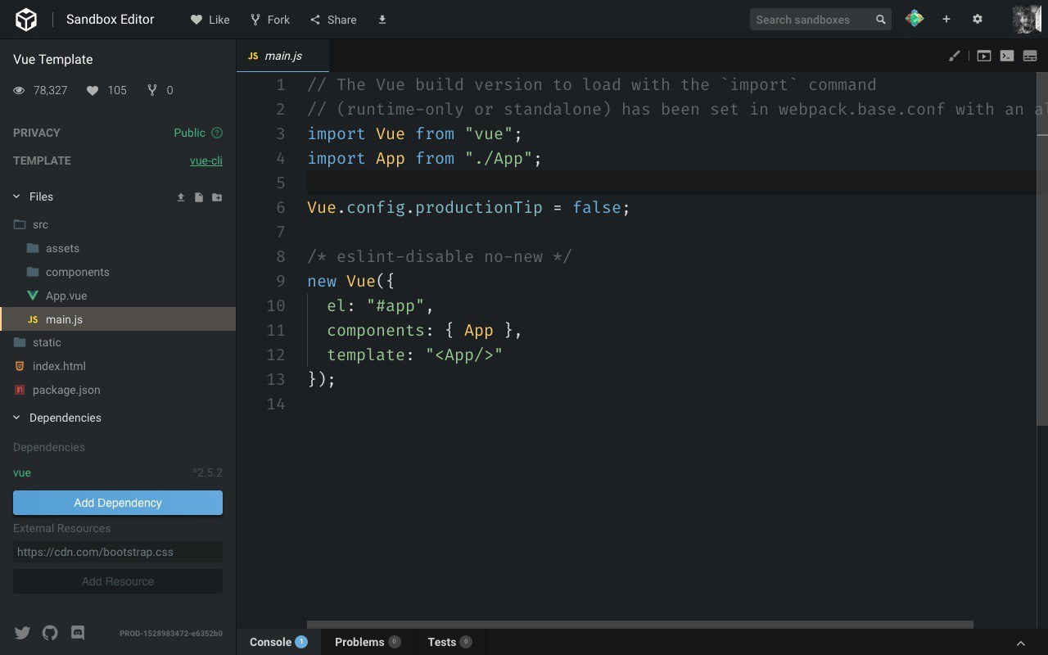

Once you're there, click the **Add dependency** button, enter "vuex" and click it. Now Vuex will be listed in the project dependencies.

To install Vuex locally you can simply run npm install vuex or yarn add vuex inside the project folder.

## Create the Vuex store

Now we are ready to create our Vuex store.

This file can be put anywhere. It's generally suggested to put it in the src/store/store.js file, so we'll do that.

In this file we initialize Vuex and we tell Vue to use it:

import Vue from 'vue' import Vuex from 'vuex'

Vue.use(Vuex)

export const store = new Vuex.Store({})

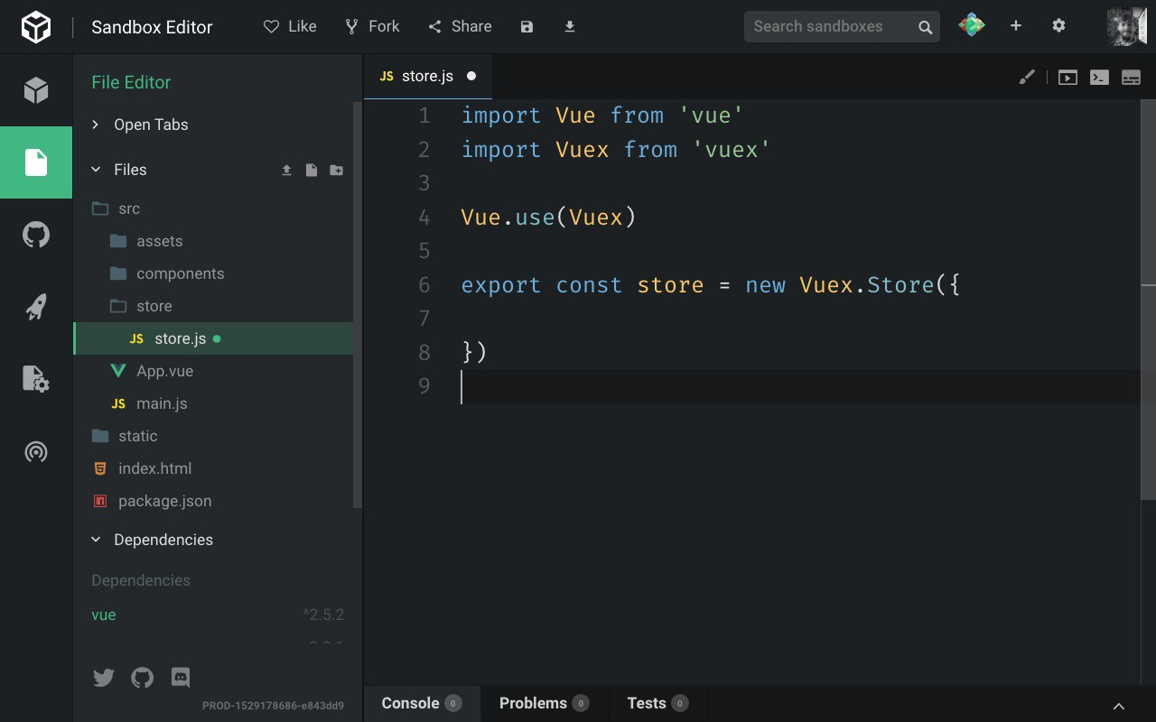

We export a Vuex store object, which we create using the Vuex.Store() API.

## An use case for the store

Now that we have a skeleton in place, let's come up with an idea for a good use case for Vuex, so I can introduce its concepts.

For example, I have 2 sibling components, one with an input field, and one that prints that input field content.

When the input field is changed, I want to also change the content in that second component. Very simple but this will do the job for us.

## Introducing the new components we need

I delete the HelloWorld component and add a Form component, and a Display component.

<template>

<div>

<label for="flavor">Favorite ice cream flavor?</label>

<input name="flavor">

</div>

</template>

<template>

<div>

<p>You chose ???</p>

</div>

</template>

## Adding those components to the app

We add them to the App.vue code instead of the HelloWorld component:

<template>

<div id="app">

<Form/>

<Display/>

</div>

</template>

<script>

import Form from './components/Form' import Display from './components/Display'

export default { name: 'App', components: {

Form, Display

}

}

</script>

## Add the state to the store

So with this in place, we go back to the store.js file and we add a property to the store called

state , which is an object, that contains the flavor property. That's an empty string initially.

import Vue from 'vue' import Vuex from 'vuex'

Vue.use(Vuex)

export const store = new Vuex.Store({ state: {

flavor: ''

}

})

We'll update it when the user types into the input field.

## Add a mutation

The state cannot be manipulated except by using **mutations**. We set up one mutation which will be used inside the Form component to notify the store that the state should change.

import Vue from 'vue' import Vuex from 'vuex'

Vue.use(Vuex)

export const store = new Vuex.Store({ state: {

flavor: ''

},

mutations: { change(state, flavor) {

state.flavor = flavor

}

}

})

## Add a getter to reference a state property

With that set, we need to add a way to look at the state. We do so using **getters**. We set up a getter for the flavor property:

import Vue from 'vue' import Vuex from 'vuex'

Vue.use(Vuex)

export const store = new Vuex.Store({ state: {

flavor: ''

},

mutations: { change(state, flavor) {

state.flavor = flavor

}

},

getters: {

flavor: state => state.flavor

}

})

Notice how getters is an object. flavor is a property of this object, which accepts the state as the parameter, and returns the flavor property of the state.

## Adding the Vuex store to the app

Now the store is ready to be used. We go back to our application code, and in the main.js file, we need to import the state and make it available in our Vue app.

We add

import { store } from './store/store'

and we add it to the Vue application:

new Vue({ el: '#app', store,

components: { App }, template: '<App/>'

})

Once we add this, since this is the main Vue component, the store variable inside every Vue component will point to the Vuex store.

## Update the state on a user action using commit

Let's update the state when the user types something. We do so by using the store.commit() API.

But first, let's create a method that is invoked when the input content changes. We use

@input rather than @change because the latter is only triggered when the focus is moved away from the input box, while @input is called on every keypress.

<template>

<div>

<label for="flavor">Favorite ice cream flavor?</label>

<input @input="changed" name="flavor">

</div>

</template>

<script>

export default { methods: {

changed: function(event) { alert(event.target.value)

}

}

}

</script>

Now that we have the value of the flavor, we use the Vuex API:

<script>

export default { methods: {

changed: function(event) { this.$store.commit('change', event.target.value)

}

}

}

</script>

see how we reference the store using this.$store ? This is thanks to the inclusion of the store object in the main Vue component initialization.

The commit() method accepts a mutation name (we used change in the Vuex store) and a payload, which will be passed to the mutation as the second parameter of its callback function.

## Use the getter to print the state value

Now we need to reference the getter of this value in the Display template, by using

$store.getters.flavor . this can be removed because we're in the template, and this is implicit.

<template>

<div>

<p>You chose {{ $store.getters.flavor }}</p>

</div>

</template>

## Wrapping up

That's it for an introduction to Vuex!

The full, working source code is available at <https://codesandbox.io/s/zq7k7nkzkm> There are still many concepts missing in this puzzle:

actions modules helpers plugins

but you have the basics to go and read about them in the official docs. Happy coding!

# Vue Router

**Discover one of the essential pieces of a Vue application: the router**

## Introduction

In a JavaScript web application, a router is the part that syncs the currently displayed view with the browser address bar content.

In other words, it's the part that makes the URL change when you click something in the page, and helps to show the correct view when you hit a specific URL.

Traditionally the Web is built around URLs. When you hit a certain URL, a specific page is displayed.

With the introduction of applications that run inside the browser and change what the user sees, many applications broke this interaction, and you had to manually update the URL with the browser's History API.

You need a router when you need to sync URLs to views in your app. It's a very common need, and all the major modern frameworks now allow you to manage routing.

The Vue Router library is the way to go for Vue.js applications. Vue does not enforce the use of this library. You can use whatever generic routing library you want, or also create your own History API integration, but the benefit of using Vue Router is that it's **official**.

This means it's maintained by the same people who maintain Vue, so you get a more consistent integration in the framework, and the guarantee that it's always going to be compatible in the future, no matter what.

## Installation

Vue Router is available via npm with the package named vue-router . If you use Vue via a script tag, you can include Vue Router using

<script src="https://unpkg.com/vue-router"></script>

unpkg.com is a very handy tool that makes every npm package available in the browser with a simple link

If you use the Vue CLI, install it using

npm install vue-router

Once you install vue-router and make it available either using a script tag or via Vue CLI, you can now import it in your app.

You import it after vue , and you call Vue.use(VueRouter) to *install* it inside the app:

import Vue from 'vue'

import VueRouter from 'vue-router'

Vue.use(VueRouter)

After you call Vue.use() passing the router object, in any component of the app you have access to these objects:

this.$router is the router object

this.$route is the current route object

## The router object

The router object, accessed using this.$router from any component when the Vue Router is installed in the root Vue component, offers many nice features.

We can make the app navigate to a new route using

this.$router.push()

this.$router.replace()

this.$router.go()

which resemble the pushState , replaceState and go methods of the History API.

push() is used to go to a new route, adding a new item to the browser history. replace() is the same, except it does not push a new state to the history.

Usage samples:

this.$router.push('about') //named route, see later this.$router.push({ path: 'about' })

this.$router.push({ path: 'post', query: { post_slug: 'hello-world' } }) //using query par ameters (post?post_slug=hello-world)

this.$router.replace({ path: 'about' })

go() goes back and forth, accepting a number that can be positive or negative to go back in the history:

this.$router.go(-1) //go back 1 step this.$router.go(1) //go forward 1 step

## Defining the routes

I'm using a Vue Single File Component in this example.

In the template I use a nav tag that has 3 router-link components, which have a label (Home/Login/About) and a URL assigned through the to attribute.

The router-view component is where the Vue Router will put the content that matches the current URL.

<template>

<div id="app">

<nav>

<router-link to="/">Home</router-link>

<router-link to="/login">Login</router-link>

<router-link to="/about">About</router-link>

</nav>

<router-view></router-view>

</div>

</template>

A router-link component renders an a tag by default (you can change that). Every time the route changes, either by clicking a link or by changing the URL, a router-link-active class is added to the element that refers to the active route, allowing you to style it.

In the JavaScript part we first include and install the router, then we define 3 **route components**.

We pass them to the initialization of the router object, and we pass this object to the Vue root instance.

Here's the code:

<script>

import Vue from 'vue'

import VueRouter from 'vue-router' Vue.use(Router)

const Home = {

template: '<div>Home</div>'

}

const Login = {

template: '<div>Login</div>'

}

const About = {

template: '<div>About</div>'

}

const router = new VueRouter({ routes: [

{ path: '/', component: Home },

{ path: '/login', component: Login },

{ path: '/about', component: About }

]

})

new Vue({ router

}).$mount('#app')

</script>

Usually, in a Vue app you instantiate and mount the root app using:

new Vue({

render: h => h(App)

}).$mount('#app')

When using the Vue Router, you don't pass a render property but instead, you use router .

The syntax used in the above example:

new Vue({ router

}).$mount('#app')

is a shorthand for

new Vue({ router: router

}).$mount('#app')

See in the example, we pass a routes array to the VueRouter constructor. Each route in this array has a path and component params.

If you pass a name param too, you have a **named route**.

## Using named routes to pass parameters to the router push and replace methods

Remember how we used the Router object to push a new state before?

this.$router.push({ path: 'about' })

With a named route we can pass parameters to the new route:

this.$router.push({ name: 'post', params: { post_slug: 'hello-world' } })

the same goes for replace() :

this.$router.replace({ name: 'post', params: { post_slug: 'hello-world' } })

**What happens when a user clicks a router-link**

The application will render the route component that matches the URL passed to the link.

The new route component that handles the URL is instantiated and its guards called, and the old route component will be destroyed.

## Route guards

Since we mentioned **guards**, let's introduce them.

You can think of them of life cycle hooks or middleware, those are functions called at specific times during the execution of the application. You can jump in and alter the execution of a route, redirecting or simply canceling the request.

You can have global guards by adding a callback to the beforeEach() and afterEach()

property of the router.

beforeEach() is called before the navigation is confirmed

beforeResolve() is called when beforeEach is executed and all the components

beforeRouterEnter and beforeRouteUpdate guards are called, but before the navigation is confirmed. The final check, if you want

afterEach() is called after the navigation is confirmed

What does "the navigation is confirmed" mean? We'll see it in a second. In the meantime think of it as "the app can go to that route".

The usage is:

this.$router.beforeEach((to, from, next) => {

// ...

})

this.$router.afterEach((to, from) => {

// ...

})

to and from represent the route objects that we go to and from. beforeEach has an additional parameter next which if we call with false as the parameter, will block the navigation, and cause it to be unconfirmed. Like in Node middleware, if you're familiar, next() should always be called otherwise execution will get stuck.

Single route components also have guards:

beforeRouteEnter(from, to, next) is called before the current route is confirmed

beforeRouteUpdate(from, to, next) is called when the route changes but the component that manages it is still the same (with dynamic routing, see next)

beforeRouteLeave(from, to, next) is called when we move away from here

We mentioned navigation. To determine if the navigation to a route is confirmed, Vue Router performs some checks:

it calls beforeRouteLeave guard in the current component(s) it calls the router beforeEach() guard

it calls the beforeRouteUpdate() in any component that needs to be reused, if any exist it calls the beforeEnter() guard on the route object (I didn't mention it but you can look [here](https://router.vuejs.org/guide/advanced/navigation-guards.html#per-route-guard))

it calls the beforeRouterEnter() in the component that we should enter into it calls the router beforeResolve() guard

if all was fine, the navigation is confirmed! it calls the router afterEach() guard

You can use the route-specific guards ( beforeRouteEnter and beforeRouteUpdate in case of dynamic routing) as life cycle hooks, so you can start **data fetching requests** for example.

## Dynamic routing

The example above shows a different view based on the URL, handling the

/

/about routes.

, /login and

A very common need is to handle dynamic routes, like having all posts under /post/ , each with the slug name:

/post/first

/post/another-post

/post/hello-world

You can achieve this using a dynamic segment. Those were static segments:

const router = new VueRouter({ routes: [

{ path: '/', component: Home },

{ path: '/login', component: Login },

{ path: '/about', component: About }

]

})

we add in a dynamic segment to handle blog posts:

const router = new VueRouter({ routes: [

{ path: '/', component: Home },

{ path: '/post/:post_slug', component: Post },

{ path: '/login', component: Login },

{ path: '/about', component: About }

]

})

Notice the :post_slug syntax. This means that you can use any string, and that will be mapped to the post_slug placeholder.

You're not limited to this kind of syntax. Vue relies on [this library](https://github.com/pillarjs/path-to-regexp) to parse dynamic routes, and you can go wild with Regular Expressions.

Now inside the Post route component we can reference the route using $route , and the post slug using $route.params.post_slug :

const Post = {

template: '<div>Post: {{ $route.params.post_slug }}</div>'

}

We can use this parameter to load the contents from the backend.

You can have as many dynamic segments as you want, in the same URL:

/post/:author/:post_slug

Remember when before we talked about what happens when a user navigates to a new route?

In the case of dynamic routes, what happens is a little different.

Vue to be more efficient instead of destroying the current route component and re-instantiating it, it reuses the current instance.

When this happens, Vue calls the beforeRouteUpdate life cycle event. There you can perform any operation you need:

const Post = {

template: '<div>Post: {{ $route.params.post_slug }}</div>' beforeRouteUpdate(to, from, next) {

console.log(`Updating slug from ${from} to ${to}`) next() //make sure you always call next()

}

}

## Using props

In the examples, I used $route.params.* to access the route data. A component should not be so tightly coupled with the router, and instead, we can use props:

const Post = {

props: ['post_slug'],

template: '<div>Post: {{ post_slug }}</div>'

}

const router = new VueRouter({ routes: [

{ path: '/post/:post_slug', component: Post, props: true }

]

})

Notice the props: true passed to the route object to enable this functionality.

## Nested routes

Before I mentioned that you can have as many dynamic segments as you want, in the same URL, like:

/post/:author/:post_slug

So, say we have an Author component taking care of the first dynamic segment:

<template>

<div id="app">

<router-view></router-view>

</div>

</template>

<script>

import Vue from 'vue'

import VueRouter from 'vue-router' Vue.use(Router)

const Author = {

template: '<div>Author: {{ $route.params.author}}</div>'

}

const router = new VueRouter({ routes: [

{ path: '/post/:author', component: Author }

]

})

new Vue({ router

}).$mount('#app')

</script>

We can insert a second router-view component instance inside the Author template:

const Author = {

template: '<div>Author: {{ $route.params.author}}<router-view></router-view></div>'

}

we add the Post component:

const Post = {

template: '<div>Post: {{ $route.params.post_slug }}</div>'

}

and then we'll inject the inner dynamic route in the VueRouter configuration:

const router = new VueRouter({ routes: [{

path: '/post/:author', component: Author, children: [

path: ':post_slug',

component: Post

]

}]

})